
Habits to better health

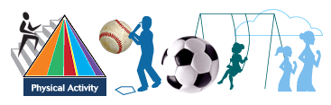


SUPPLEMENT:

CORRESPONDING LESSONS AND ACTIVITIES

#1
Learn the right way to wash your hands.

DISCUSSION:
One of the most important times to wash our hands is before we eat. Our hands have touched many things, and each of the things we have touched had germs on them. If we do not clean or wash our hands before we eat, those germs will get where we don’t want them to be. Many of those germs can be harmful to our bodies. Washing our hands is a simple way of preventing that from happening!

SUPPLIES:
Water, paper towels, soap (either bar of liquid), bucket or sink, timer if needed.

ACTIVITY:
Practice the following steps:

- Wet your hands with warm, running water and put liquid soap or soap from a clean soap bar on your hands. Lather well.

- Rub your hands vigorously together for 15 seconds. Reciting the alphabet or singing happy birthday to yourself while rubbing your hands will take at least 15 seconds.

- Scrub all services, including the backs of your hands, wrists and between your fingers and under your fingernails.
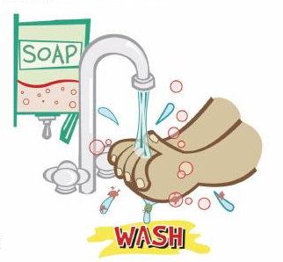
- Rinse well.

- Dry your hands with a clean or disposable towel.

- Use the towel to turn off the water and open the door of the bathroom as you leave.

Go home and show your family how to wash your hands, especially before meal time!!

#2
Understand the Food Guide Pyramid.

DISCUSSION:
This pyramid reminds you to make good food choices everyday and to be active. Notice that some of the color stripes are wider than others. The different sizes remind you to choose more foods from the food groups with the widest stripes. You should also remember to eat foods from all five food groups every day

ACTIVITY:
Think about what you ate yesterday and then study the Food Guide Pyramid to conﬁrm that all food groups were included in the days' diet. Discuss which food groups are represented in your last meal today or when your family eats together.

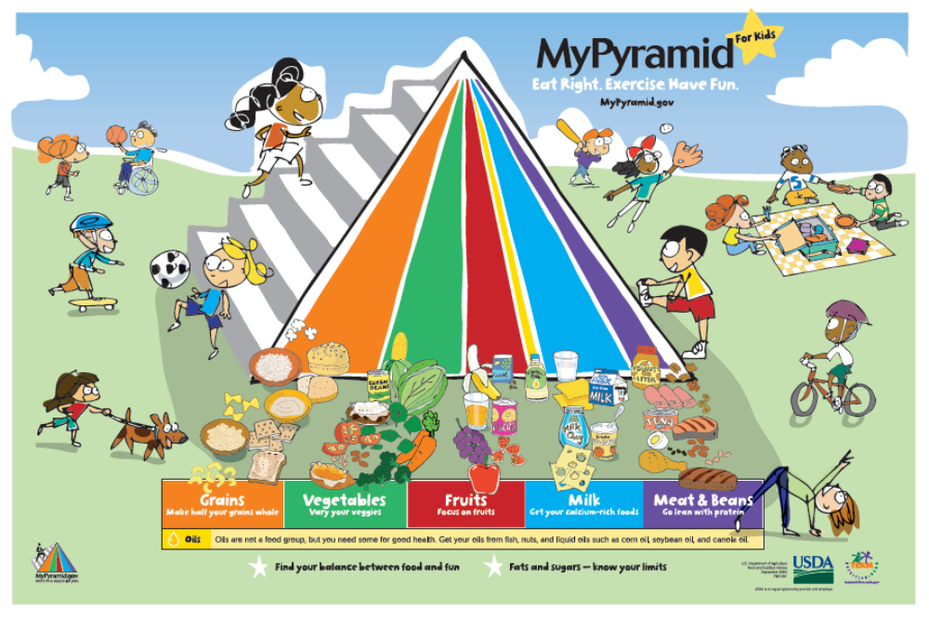
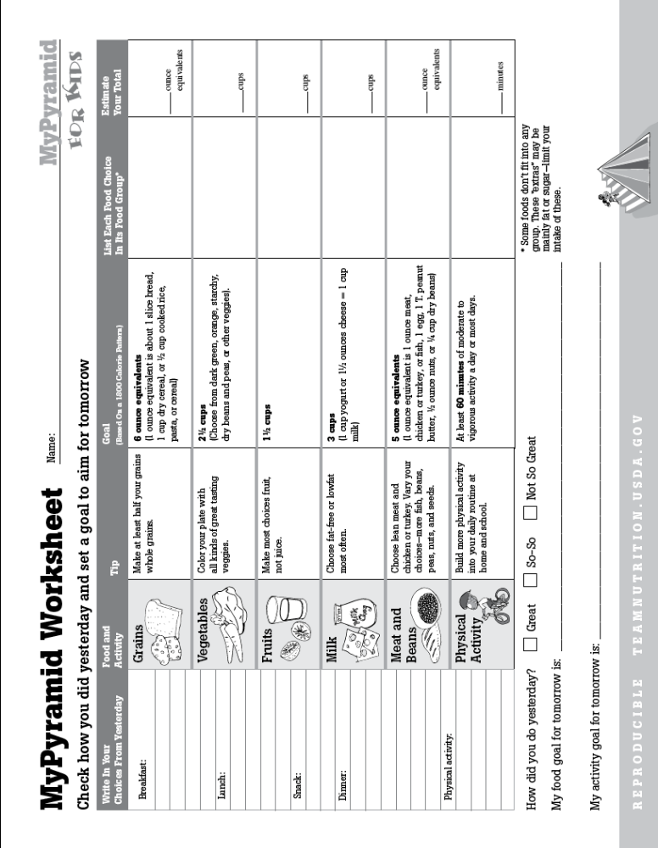
#3
Discover: Protein, Dairy, Vegetable, Fruit, Starch, and Fat.

DISCUSSION:
Our food guide pyramid is made up of 6 different items. Each Item or “food group” has an important job to make our bodies happy and healthy. Below is a listing of the foods that are important for growth and maintenance. Discuss the following food groups and see if you know why each food group is important for that happy and healthy body!

Protein: Protein is found mostly in animal products. It is also in peanut butter and tofu. Items such as milk, yogurt, cottage cheese and cheese are included. Nuts are also a good source of protein as well as Tofu. Its main job in our body is to repair and build tissue such as muscle and skin!

Dairy: Dairy foods include items from the cow, such as milk, cheese, cottage cheese, yogurt, ice cream, half and half. These items provide important calcium for out bones, drink or eat these items at least 3 times per day to get the calcium we need.

Vegetable: There are plenty of vegetables to enjoy -- broccoli, cauliflower, green beans, carrots, lettuce, zucchini, cabbage, celery, asparagus, and mushrooms. This food group provides us with fiber as well as vitamins and minerals. Minerals and vitamins help our body run all its important jobs correctly.

Fruit: Fruits grow in many colors. They provide fiber, vitamins and minerals of all kinds. Fruits have seeds, for example: tomato (yes it is a fruit, it has seeds !!), apples, oranges, watermelon, melon, kiwi, pears, grapefruit, grapes. The darker the color the better, so go for the deep dark colors! This food group provides us with fiber, just like the vegetables, but fruits also provide us with other vitamins and minerals than vegetables. That is why they are in a different food group.

Starch: Starches provide some protein, fiber, vitamins and minerals. There is a wide variety: bread, potato, tortilla, beans, peas and corn (these two are a heavy vegetable, so they become a starch), cornbread dressing, muffins, macaroni or pasta. Starches provide some fiber and most importantly, vitamins such as the B vitamins. These vitamins help processes in the body run smoothly, just like the vegetables and fruits.

Fat: Fats are very high in calories, but there are good and bad fats. To make it easier to remember, fats are the greasy items -- margarine, butter, oils. The best fats to eat are the ones that come from a plant source, the animal source of fat can be harmful to the body if eaten in large amounts. The fats in meats and dairy products contain the fats we need to watch, so use these items in the low-fat to no-fat form. Fats can also be important to us in many ways such as cushioning our organs against injury.
ACTIVITY:
On a piece of paper, list your favorite items in each of the food groups provided.

Protein:

Diary:

Vegetable:

Fruit:

Starch:

Fat:

#4
Eat “5 A Day”!

DISCUSSION:
“5 A Day” means eating five or more servings of fruits and vegetables every day. More is better when it comes to fruits and vegetables. They taste great, give you energy through the day, and in general are:
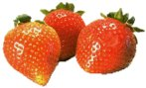
- colorful and crunchy
- easy to prepare and carry
- low in fat
- low in calories
- full of vitamins, minerals and fiber

ACTIVITY:
Take the “5 A Day Challenge” to see how easy it is to add fruits and vegetables to your diet (do any or all of the following):

- Find out who has the largest selection of fruits and vegetables in their home.

- Count the number of fruit and vegetable servings each person has eaten at breakfast, lunch, dinner and snacks. Award a special prize to those who have eaten at least 5 servings each day.

- Make snacking more interesting by competing with friends to see who can snack on the largest variety of fruits and veggies.

- See who can plan the most interesting "5 A Day" menu.

#5
Get 3 servings of low-fat dairy in your diet.

DISCUSSION:
Eating 3 servings a day of dairy foods, with exercise, is an important way for you to build stronger bones. Nutrients in diary foods include calcium, magnesium, phosphorus, potassium, protein, and vitamin D. All of these work together to build and protect bones.

ACTIVITY:
Learn what a serving of dairy is:

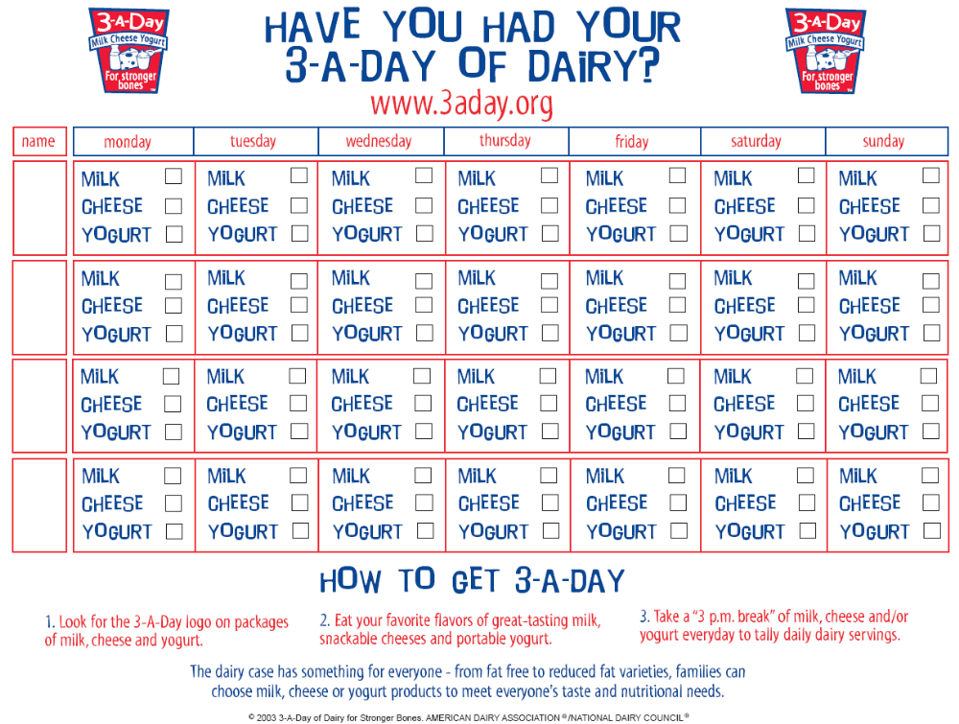Then record your intake of dairy throughout the day for one whole week.
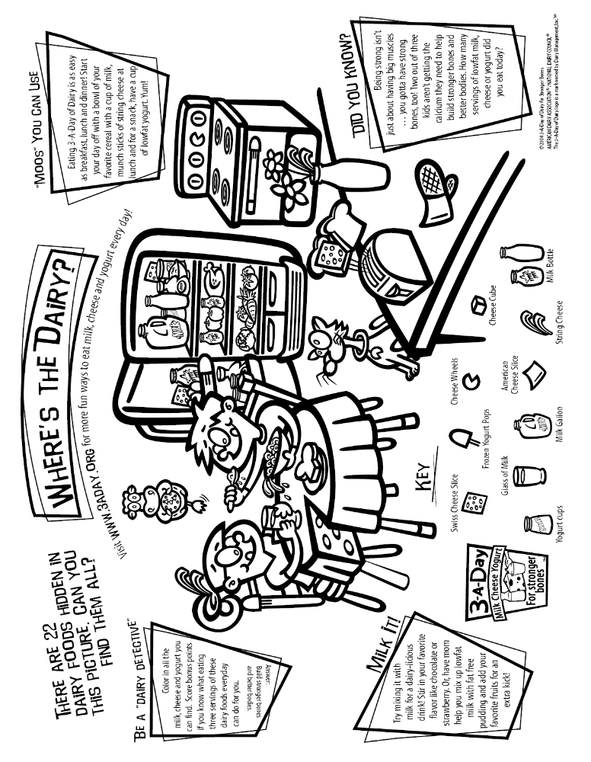
#6
Balance your food choices.

DISCUSSION:
Understanding the food groups of the food guide pyramid is important. But, it is nice to know that the foods we like can fit into a pyramid, just like the foods that we do not like. Put your favorite foods in the food groups of the blank food guide pyramid. If you have too many in one group and not enough in another, research your favorite food. Are there others you can exchange to make the pyramid more balanced? That is the goal, make it balanced so that there is a variety of the foods you eat on a daily basis.

SUPPLIES:
Pencil, picture of blank food guide pyramid (attached).

ACTIVITY:
Students add their own foods to the pyramid, to help them learn where their favorite foods fit in the pyramid.
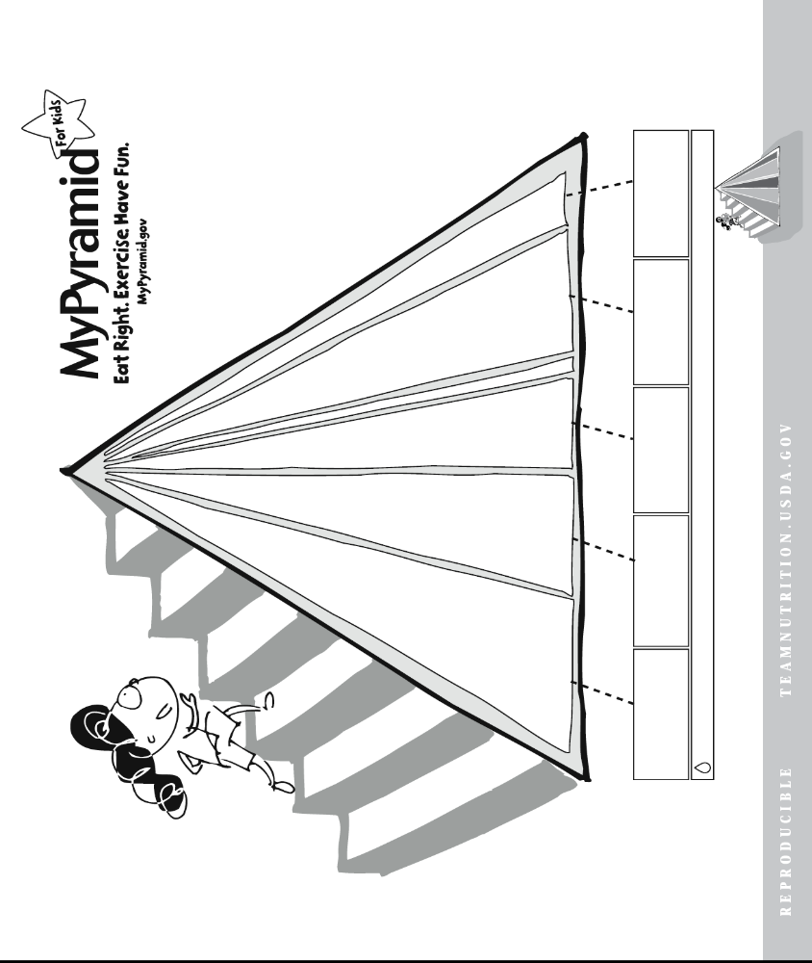
#7
Keep nutritious snacks on hand!

DISCUSSION:
Snack intelligently. Be creative and choose snacks from different food gourps. Snacks created from fresh fruits, vegetables, and dairy are refreshing, healthy, delicious, and when you get those afterschool munchies!

ACTIVITY:
Mark which one of these snacks you would like to try at home. Create more recipes.
http://www.newenglanddairycouncil.com/health/counseling/pdf/TerrificallyTastySnacks1.pdf

- Tropical Smoothie Blend fresh orange slices with strawberry yogurt and ice.
- Cucumber Salad Mix diced cucumber with a cup of lowfat plain yogurt, mint and a pinch of salt and pepper
and spread on whole-wheat pita wedges.
- Mango Mixer Blend mango, plain lowfat yogurt and a splash of pineapple juice.
- Out of the Bowl Get an energy boost with a cold glass of fat free milk and handfull of whole grain cereal.
- Strawberry-sicles Mix lowfat strawberry milk with fresh strawberry slices and freeze in a popsicle container.
- Flavor on-the-Fly Fat free flavored milks are perfect anywhere you go- just take, shake and sip!
- Salsa Roll-Up Roll Monterey Jack cheese into a whole-wheat tortilla and dip in salsa.
- Cheddar Crunch Mix ½ cup of Cheddar cheese shreds with popcorn and pretzels.
- Veggie Wraps Wrap Colby Jack cheese around spears of asparagus.
- Create Your Own: __________________________________________________________
__________________________________________________________
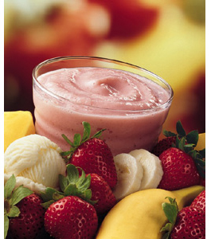
#8
Count your gulps.

DISCUSSION:
Drinking plenty of water helps you stay healthy, does not harm teeth and boosts energy levels. The benefits of drinking water are:

Health & hydration
- water is sugar, calorie and additive free
- it is the healthiest, most natural thirst quencher
- doesn’t harm teeth
- helps prevent tiredness

Mental and physical
- increases energy levels
- boosts brainpower

Water is the most important source for basic hydration for kids engaged in a sport. The American College of Sports Medicine recommends that children count gulps:

• 8 to 16 gulps before an activity (4 to 8 ounces).

• 8 gulps during an activity (4 ounces every 15 to 20 minutes).

• 32 gulps after an activity (16 ounces).

ACTIVITY:
Fill one glass with water. Count the number of gulps it takes to drink it and estimate how may ounces was in the glass.

#9
Eat more fruits and vegetables every day.

DISCUSSION:
As part of a healthy diet, eating fruits and vegetables instead of high-fat foods may make it easier to control your weight over time. Eat a fruit for lunch everyday and make dessert a piece of fruit a rather than an everyday junk food treat.

ACTIVITY: http://www.ces.purdue.edu/new/Low_Literacy_Brochure.pdf
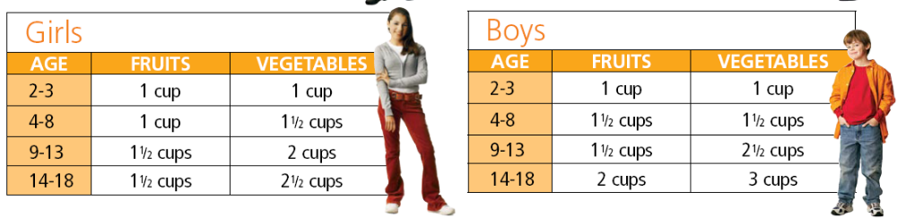
Find out how many fruits and vegetables you need in a day.
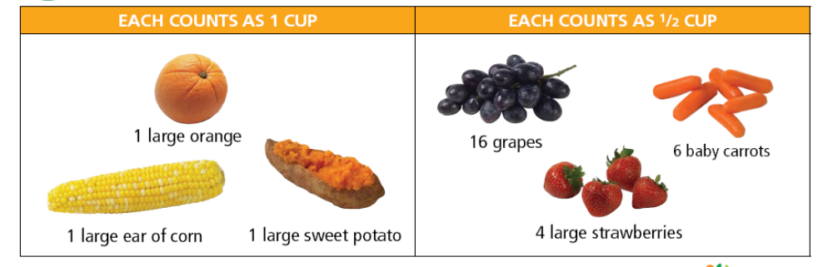
Learn what ½ cup and 1 cup of fruit look like:
Circle the ideas that you will try this next week at home
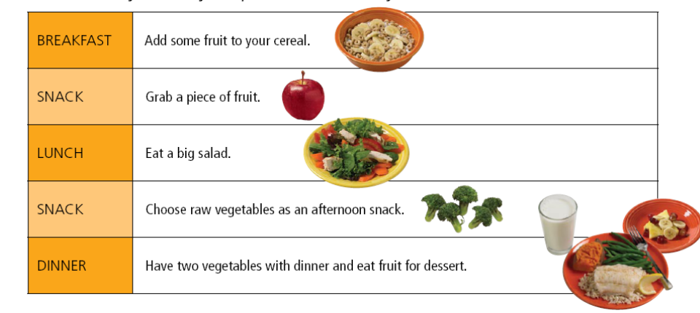
#10
Go grocery shopping with your parents.

DISCUSSION:
It’s easy to stick with the same safe foods you’ve always consumed and to not push yourself to try something new. Grocery shopping excursions are a fun way to get see different foods that you haven’t tried yet. As you grocery shop, make sure you get food items from all the food groups of the food guide pyramid. The goal is to try new foods and see if you can make your pyramid more complete!

ACTIVITY:
List new foods that you would be willing to try. After trying it, share your experiences with your family or class. Did you like it or not. If you like it well enough, place it on your #3 worksheet, items of the food groups.
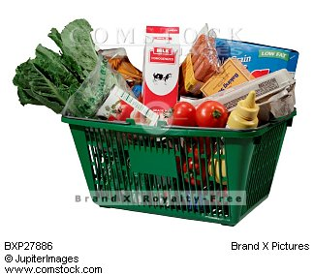
Protein:____________________________________

Diary: ______________________________________

Vegetable: _________________________________

Fruit: _______________________________________

Starch: _____________________________________

Fat: ________________________________________

#11
Be aware of portion distortion.

DISCUSSION:
People have learned over time, to eat more and more, not paying attention to portion sizes. Portion sizes ensure that we are giving our bodies the nutrients it needs in the correct size. When we compare how portion sizes have changed, we see how Americans are feeding their bodies more than they really need and why they are gaining so much weight. It pays to pay attention.

ACTIVITY:
Print the following on cardstock and compare common portion sizes of foods we eat.

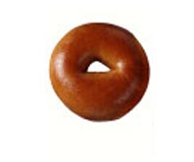
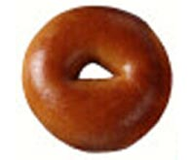
BAGEL

20 YEARS AGO – 3” diameter TODAY – 6” diameter

CHEESEBURGER
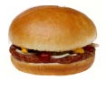
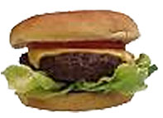

20 YEARS AGO – 333 calories TODAY – 590 calories

FRENCH FRIES
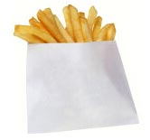
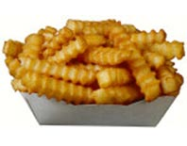

20 YEARS AGO – 2.5 oz TODAY – 7 oz

SODA
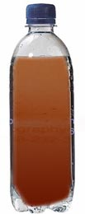
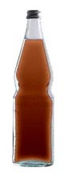

20 YEARS AGO – 6.5 oz TODAY – 20 oz
85 calories 250 calories

#12
Keep an eye on your portion size.

DISCUSSION:
It is important to know portion sizes. Over the years portion sizes of food have grown. For instance, years ago the a typical fast food meal (original burger, fries, and Coke) totaled about 600 calories. Today, a super sized value meal adds up to over 1500 calories. Knowing portions is a healthy habit.

ACTIVITY:
Display and discuss the following portion sizes:

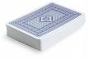Deck of playing cards | 3 ounces of meat, poultry, or fish
Matchbook | 1 ounce of meat, poultry, or fish; pat of margarine
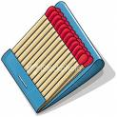  Baseball | 1 cup of canned fruit or 1 medium orange/apple
  Three ice cubes | ½ cup of chopped veggies
Fist or a tennis ball | 1 cup of potatoes, rice, or pasta
Hockey puck | 1 standard bagel
CD Jacket | 1 piece of bread
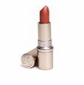  Golf ball | 2 tablespoons of peanut butter
Four dice or a tube of lipstick | 1 ounce of cheese

#13
Be realistic with food and exercise changes.

DISCUSSION:
Unless you are very disciplined, it’s unrealistic to completely ban habits that you believe are bad for you. Instead, try limiting your intake of things, like cookies and candy, making them an occasional treat. Keep serving sizes small—no king-size bars or bags. Fun-size treats are perfect. Sodas should be a very occasional treat, and keep the serving size small. With exercise, limit computer, TV or videogame time, and then go outside to play with a ball or ride your bike. As you begin to make baby step changes, it will all add up to positive habits for health.

ACTIVITY:
Think about some of the habits that you want to change. Do you drink too much soda? Do you not eat enough fruits and vegetables? Do you watch a lot of TV? Now, fill in the blanks below as you decide what realistic change you will make to develop a positive habit for health.

1. I eat too much: _____________________________________________
I will change by: _____________________________________________
2. I spend too much time: _____________________________________________
I will change by: _____________________________________________
3. I don’t do enough of: _____________________________________________
I will change by: _____________________________________________

#14
To portion snacks, make your own snack pack.

DISCUSSION:
One easy way to make sure we are eating the right portion sizes is by looking at the box/bag of foods we are eating. Below is an exercise to help us learn what a serving size is of certain foods. It is fine to have certain foods, but best if it is in the portion sizes that the box/bag suggest. See if your portion sizes are bigger than the suggestions on the box.

SUPPLIES:

Boxes of foods (ie, Fig newton’s, oreos, crackers, chips), plastic bags

ACTIVITY:
- Divide the boxes of the food items between the tables to be used.
- Provide plastic bags to each table as well.
- Have the students wash hands before starting project.
- Students to put on plastic gloves
- Have students place the crackers or cookies on the paper towels to empty out the food boxes of its contents.
- Look at the label on the box of the items dumped.
- Have the students divvy up the contents into the zip lock bags as each serving size suggests.
- This is now your new portion control serving. It may not be exactly 100 calories, but will be close enough.
- This is what your portion size should be; now divvy up the whole box for future use.

#15
Portion your dinner plate.

DISCUSSION:
An easy way to make sure your meals are balanced and that your portions are reasonable is to look hard at your plate. In your mind, divide your plate in half. Fill one half with vegetables and/or fruits. Divide the other half into smaller quarters and then fill with roughly equal amounts of starch and a high-protein food. piece of paper and drew a big, round circle with a line through the middle. If you're still hungry after eating that meal, have another plate of vegetables, and then you're done. It's that simple!

ACTIVITY:
Label each area of the plate with the appropriate food group.

#16
Plan ahead.

DISCUSSION:
Plan ahead. If you know you are going out to a big dinner, cut back on calories earlier in the day. If you’re taking a long car trip somewhere, bring healthier foods with you so you don’t spend a day living on fast food, candy bars, chips, and soda. If it’s a special occasion or a holiday buffet, decide to fill up on the few foods that are your favorites, rather than eating a little of everything. Thinking and planning ahead will keep you on the road to good habits for better health.

ACTIVITY:
You’re going on a roadtrip! Take an ice chest with you and write down some smart choices of food to pack with you that will keep you feeling good. Share your answers with the class.
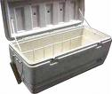

Instructor Ideas: Napkins, wet wipes, plastic utensils, and a couple empty plastic shopping bags to use for trash.
* Cleaned and sliced raw vegetables; grape or cherry tomatoes
* Apples, oranges, bananas, grapes
* Snack size dried fruit (such as raisins)
* String cheese
* Yogurts in a tube
* Pretzels
* Roasted soy nuts
* Baked, flavored rice or popcorn cakes
* Sugar free jello cups / fat-free pudding cups (with plastic spoons)
* Reduced fat cookies/crackers
* Fruit juice boxes; mini cans of low-sodium V8 juice
* Whole wheat bagels with light cream cheese (bring a plastic knife; slice bagels before leaving)
* Sandwiches made with lean luncheon meats and low-fat cheese or hummus and fresh spinach
#17
Make each meal last at least 20 minutes.

DISCUSSION:

Eat slowly. Chew your food well. This means at least 10-20 chews per bite of food. And no, you can't just take bigger bites so that this is a reasonable amount of chews; take small bites also. Remember that it takes about 20 minutes for your full-feeling to get into your stomach, regardless of how much you eat. You could eat 10 plates full of food, and as long as you did it within a few minutes, you still wouldn't feel full. Likewise, you can eat just a small portion and feel full the same amount of time later. Eating slowly helps to keep the amount of food you're eating small until you feel the full feelings. It also prevents you from gorging yourself, and gives you more time to accurately reflect on whether your stomach feels full yet or not. It takes a whole 20 minutes for your stomach to send the message to the brain that you are full, so you could be eating 20 minutes more than your body wants. Eating slowly makes this excess food amount lower and sometimes even nothing at all.

ACTIVITY:
See how long it takes to eat an apple when you chew slowly. Set the clock. Start it with your first bite of the apple. Then chew, chew, chew at least 10 times before swallowing and taking the next bite. Stop the clock when you are done with the apple. Compare your time with your classmates.

#18
Start smart. Eat breakfast.

DISCUSSION:
Eat breakfast every day. It really is the most important meal of the day, and it should be a substantial meal. This also starts your metabolism going early in the morning (since it slows down at night because you haven’t eaten anything for a while). You may find that you can also focus better throughout the day! If you skip breakfast, you’re more likely to eat more later on in the day.

ACTIVITY:

Breakfast Quiz

1. January is:
- National Nutrition Month

Resolve to Eat Breakfast Month
- Get Moving and Get Fit Month

2. What cereal is known as “The breakfast of champions”?

Answer: Wheaties

3. True or False: Three out of four children, ages 6-11, begin every morning with
breakfast.

4. What cereal only contains 100 calories, but has 100% of the US Dept of Agriculture’s
recommended Daily Value of 12 essential vitamins and minerals?
Answer: Total

5. What does eating a “complete breakfast” mean?
- You eat everything on your plate.
- You eat something from every food group.
- You eat foods from at least three food groups.
- You eat eggs with toast, juice, milk, and cereal.
#19
Keep a diary of your eating behaviors for 1 week.

DISCUSSION:
Emotional eating is the practice of consuming large quantities of food -- usually "comfort" or junk foods -- in response to feelings instead of hunger. Experts estimate that 75% of overeating is caused by emotions. Many of us learn that food can bring comfort, at least in the short-term. As a result, we often turn to food to heal emotional problems. Eating becomes a habit preventing us from learning skills that can effectively resolve our emotional distress. Depression, boredom, loneliness, chronic anger, anxiety, frustration, stress, problems with interpersonal relationships and poor self-esteem can result in overeating and unwanted weight gain.

ACTIVITY:
Keep a diary of your eating behaviors for 1 week and see how you eat. Do you eat 3 meals daily or snack too much? Sometimes we eat when we are not hungry. Many times this is due to emotions or how we feel. We may not even be hungry, but we want to eat, because it makes us feel better. This is not the best way to eat. Try to monitor how you eat for a few days. Do we eat emotionally? This means because of how we feel, not because we are hungry. See how you eat and see if there needs to be a change, are we eating because it makes us feel happier or are we eating because we are actually hungry!!

#20
Stay busy doing things that you enjoy.

DISCUSSION:
People often eat when they are bored. Try starting an activity that is difficult or impossible to do while eating to keep “the munchies” away. The activities should be something that you enjoy doing and is easy to start! For example, sing a song, do some crafts, look at photographs, chew gum, play outside, build models, do house cleaning, toss a frisbee, walk the dog, organize a drawer, etc.

ACTIVITY:

THINGS THAT I ENJOY DOING

In the space below, write down 10-15 things you could do instead of snacking when you’re feeling bored or hungry. These activities should be things that make it hard for you to eat while you are doing them.

1.
2.
3.
4.
5.

6.
7.
8.
9.
10.

#21
Praise yourself everyday!

DISCUSSION:
Give yourself a pat on the back for getting a little exercise or following your eating plan. On days that you weren’t perfect, find something you did right. Don’t dwell on negative thoughts or excuses. Research has shown that anticipating excuses may be the single best way of defeating them.

ACTIVITY:
For each of the following negative thoughts, provide a positive thought to counter it.

Negative Thoughts | Positive Counterthoughts
I look terrible. I will never be able to be how I want to be. | I've got to begin somewhere. It won't hurt to try.
I'm as big as a house. | Who wouldn't be if they ate like me and were as inactive as I am? Besides, houses are built to suit their owners. They can be modified to fit their owners. And that's what I'm doing.
I've really had a busy day and I am just wiped out. I don't need to exercise because I burned up a lot of calories running around school all day. | If I add the calories that I burn up from exercising it will be just that much more. Exercising always gives me a lift.
It's impossible for me to resist this (e.g., a cookie) for they are my favorites | I'm not on a diet and can eat the things I like. But if I eat this now, it will be an extra snack. Am I really saying that I have no control over what I do? I can resist eating anything I want to.
Eating like this is stupid. | It sure is nice to taste and enjoy food for a change. I didn't know what I was missing when I was shoveling it in

#22
Make sure you warm up before exercising.

DISCUSSION:
Make sure you warm up before exercising. This is done by stretching, slow movements and deep breathing. This warming up can help to prevent injury to muscles and bones. To keep them happy, we warm up and let them get used to being used. Below are some suggestions for proper stretching. See is you can do these and prevent unwanted injury!
To get ready for exercising, make sure your clothing and accessories are right. Here are a few tips to help get ready for exercising:

- Wear clothing that is loose, but not too loose to have to worry about it.
- Do not dress too light nor too hot, t-shirts and shorts are the best.
- Tennis shoes should have good support, not flat for running. No cleats either. Regular running or walking tennis shoes are good. IF the support is not there for the exercise, then one can hurt feet and backs.
- Socks are a must. Height of the socks is not limited.
- Carry water with you if you are out and about.
- Sunscreen is important for all activities; cover your neck and the ears!

When stretching:
- Stretch ever so slowly, do not overextend, you can hurt yourself. Do not bounce while stretching.
- Stretch all muscles that will be affected by the exercise
- Stretch for about 10-15 minutes before any exercise.
- Make sure to breathe deep breaths as well to get the body ready for exercise.
- Go and enjoy the weather and exercise carefully!

ACTIVITY:
Reach up with your arms as far as you can. Stretch! Sway from one side to the other. Stretch one arm up high. Now stretch the other up high. Alternate first the other arm (to the count of 8 (1 2 3 4 5 6 7 8). Stretch your arms out to the side. Stretch your arms out in front of you. Stretch your arms behind you. Move other parts of your body, such as your hands, your elbows. Try your shoulders; move your head from side to side.
ADDITIONAL RESOURCES:

Warm Up Activities and Stretching Exercises
http://www.thestretchinghandbook.com/archives/print/warm-up_p.php

The warm up activities are a crucial part of any exercise regime or sports training. An effective warm up has a number of very important key elements. These elements, or parts, should all be working together to minimize the likelihood of sports injury from physical activity.

Warming up prior to any physical activity does a number of beneficial things, but primarily its main purpose is to prepare the body and mind for more strenuous activity. One of the ways it achieves this is by helping to increase the body's core temperature, while also increasing the body's muscle temperature. By increasing muscle temperature you're helping to make the muscles loose, supple and pliable.

An effective warm up also has the effect of increasing both your heart rate and your respiratory rate. This increases blood flow, which in turn increases the delivery of oxygen and nutrients to the working muscles. All this helps to prepare the muscles, tendons and joints for more strenuous activity.

Keeping in mind the aims or goals of an effective warm up, we can then go on to look at how the warm up should be structured.

Obviously, it's important to start with the easiest and most gentle activity first, building upon each part with more energetic activities, until the body is at a physical and mental peak. This is the state in which the body is most prepared for the physical activity to come, and where the likelihood of sports injury has been minimized as much as possible. So, how should you structure your warm up to achieve these goals?

There are four key elements, or parts, which should be included to ensure an effective and complete warm up:
- The general warm up;
- Static stretching;
- The sports specific warm up; and
- Dynamic stretching.
All four parts are equally important and any one part should not be neglected or thought of as not necessary. All four elements work together to bring the body and mind to a physical peak, ensuring the athlete is prepared for the activity to come. This process will help ensure the athlete has a minimal risk of sports injury.

Lets have a look at each element individually.
- General warm up
The general warm up should consist of a light physical activity. Both the intensity and duration of the general warm up (or how hard and how long), should be governed by the fitness level of the participating athlete. Although a correct general warm up for the average person should take about five to ten minutes and result in a light sweat. The aim of the general warm up is simply to elevate the heart rate and respiratory rate. This in turn increases the blood flow and helps with the transportation of oxygen and nutrients to the working muscles. This also helps to increase the muscle temperature, allowing for a more effective static stretch. Which bring us to part two.
- Static stretching
Static stretching is a very safe and effective form of basic stretching. There is a limited threat of injury and it is extremely beneficial for overall flexibility. During this part of the warm up, static stretching should include all the major muscle groups, and this entire part should last for about five to ten minutes. Static stretching is performed by placing the body into a position whereby the muscle, or group of muscles to be stretched is under tension. Both the opposing muscle group (the muscles behind or in front of the stretched muscle), and the muscles to be stretched are relaxed. Then slowly and cautiously the body is moved to increase the tension of the muscle, or group of muscles to be stretched. At this point the position is held or maintained to allow the muscles and tendons to lengthen. This second part of an effective warm up is extremely important, as it helps to lengthen both the muscles and tendons which in turn allows your limbs a greater range of movement. This is very important in the prevention of muscle and tendon injuries.
- Sport specific warm up
With the first two parts of the warm up carried out thoroughly and correctly, it is now safe to move onto the third part of an effective warm up. In this part, the athlete is specifically preparing their body for the demands of their particular sport. During this part of the warm up, more vigorous activity should be employed. Activities should reflect the type of movements and actions which will be required during the sporting event.
- Dynamic stretching
Finally, a correct warm up should finish with a series of dynamic stretches. However, this form of stretching carries with it a high risk of injury if used incorrectly. It should really only be used under the supervision of a professional sports coach or trainer. Dynamic stretching is more for muscular conditioning than flexibility and is really only suited for professional, well trained, highly conditioned athletes. Dynamic stretching should only be used after a high level of general flexibility has been established.

#23
Walk or ride your bike today.

DISCUSSION:
You should try to get at least 60 minutes of exercise a day. Listening to your favorite music during a daily routine of walking, jogging, or bike riding will help the time pass quickly.

ACTIVITY:
List places that you can walk to:
(ie. Around the block, corner store, school, church, etc)

1.

2.

3.

4.

5.

List places that you can ride your bike to:
(ie. Store, post office, grocery store, library, etc)

1.

2.

3.

4.

5.

#24
Plan exercises/activities for when you’re alone.

DISCUSSION:
Some people prefer exercising alone rather than with others. It sometimes helps individuals focus on their routines better. However, remember to not exert yourself too much to the point where you are not able to carry on a conversation with someone, if another person walked into the room. You should also remember that ANY type of physical activity will have some great effect, including walking, house cleaning, dancing, gardening, and climbing stairs. Here are some more ideas:
- jump rope
- fly a kite
- do cartwheels
- shoot baskets

ACTIVITY:
Plan 5 fun activities or exercise sessions to do by yourself. Then go home and do it!

1.

2.

3.

4.

5.
#25
Plan exercises/activities to do with your family.

DISCUSSION:
It’s been said that a family that works out together stays healthier and has more fun! One of the biggest challenges of families doing this is finding the time to do it. Remember, though, family fitness time doesn’t have to take a lot of time. Just a half hour walk together can add up each day. The best goal you can make with your family is to make time for fitness and health and set aside regular times and days of the week to meet for a workout. Here are some more ideas:
- go biking
- take a walk together
- play at the park
- have a "turn-off-the-TV-day"

ACTIVITY:
Plan 5 fun activities or exercise sessions to do with your family. Then go home and share your ideas with them.

1.

2.

3.

4.

5.
#26
Plan exercises/activities to do with friends.

DISCUSSION:
Exercising with friends is a good way to make fitness more enjoyable. Friends make a great support system and can help encourage you to continue exercising when you don’t feel like doing it. Here are some ideas:
- play games like dodge ball or tag
- dance to your favorite music
- play a team sport at school or at a park

ACTIVITY:
Plan 5 fun activities or exercise sessions to do with your friends. Then go and share your ideas with them.

1.

2.

3.

4.

5.

#27
If you can’t go outside, try an exercise tape.

DISCUSSION:
It is important to exercise as often as we can, but sometimes the weather does not allow us to do what we like out of doors. If you can’t go outside to exercise, bring the exercising indoors. Turn on the TV and see if there are exercise classes on the tube. If not, purchase a tape from the store or borrow one from the library to use. You might want to sign up for an activity or exercise class at the local YMCA or in-door gym as well. This will help to keep you moving and happy. Use the suggestions below with the adults. Maybe they will exercise with you.!

ACTIVITY:

Look at the list of exercise programs below. Circle the ones that interest you.
Aerobic
Dancing
Body conditioning
Kickboxing
Pilates
Step Aerobics
Stretching
Tae Boe
Yoga

#28
Learn the Activity Pyramid!

DISCUSSION:
The Physical Activity Pyramid is a guide to healthy choices for activity and fitness! It suggests activities to do everyday, for strength, for recreation, and so forth. Try to be active for a total of 60 minutes everyday, even if in small bursts. And most importantly, regardless of the type of exercise you choose to do, have fun!
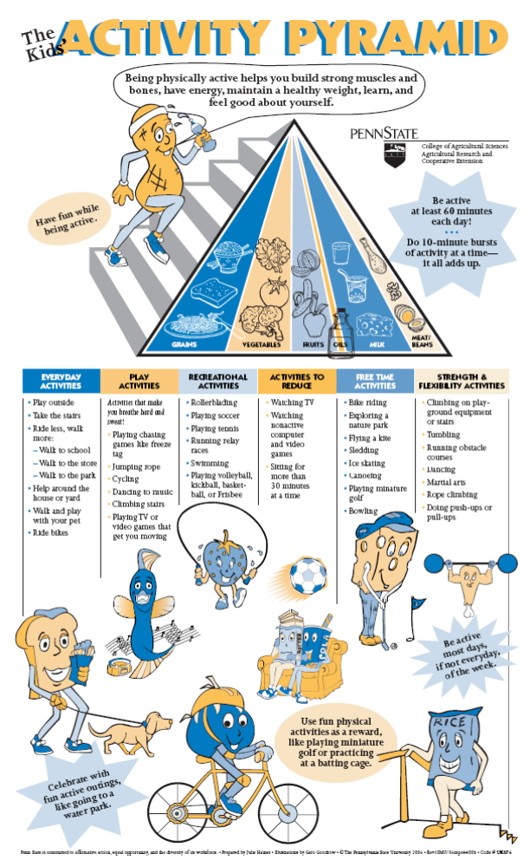

ACTIVITY:
This is your own personal physical activity pyramid. List your physical activities for a week.
Or draw and color a picture of you doing your activity in the correct space.
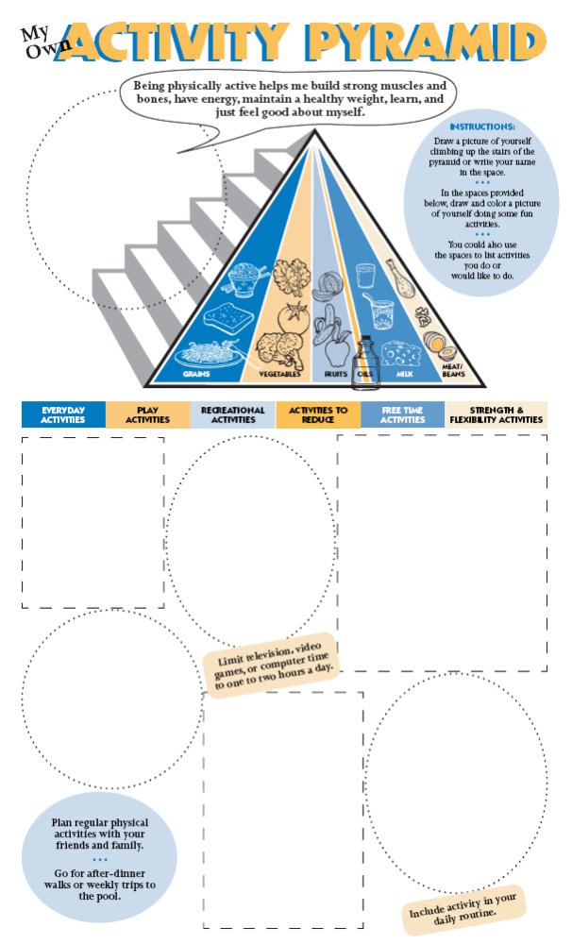
#29
Make sure you get at least 8 cups of fluid a day.

DISCUSSION:
It is very important to get the fluids we need to stay hydrated. 8 cups of fluid (64 ounces) is the suggested amount to drink. Water is the best kind of fluid.

SUPPLIES:
Measuring cups; multiple items to use for water bottles – must hold 8 cups; water

ACTIVITY:
To get the recommended water needed per day, measuring how much water you need may help you understand the importance and the quantities needed to meet those needs. Here are a few suggestions to help you understand how much water you need daily.

- Obtain a measuring cup and a container that will hold 8 cups of water
- Carefully pour 8 cups of the fluid into the container.
- Examine how much water is in the container.
- Can you tell if you drink that much in a day? Determine how you can make sure you can consume 8 cups of fluid a day.
- Write down your suggestions on how to get the 8 cups of fluid in daily.
______________________________________________________________________
______________________________________________________________________
______________________________________________________________________
______________________________________________________________________
______________________________________________________________________
______________________________________________________________________
______________________________________________________________________
______________________________________________________________________
______________________________________________________________________

#30
If water is not your favorite beverage, what to do.

DISCUSSION:
Here in the dessert, water is very important. It is difficult to get all the water you need. We need to have water daily to keep our bodies happy. Water is needed to keep our skin from drying out, keep our lips moist and keep hair and nails healthy. Look below to see how we can get the important fluids we need!

SUPPLIES:
Water/Ice, Cups, Flavoring things for water: New Flavor Packets available: propel, Kool-Aid, Wal-Mart brand packets, Fruit juice, seltzer water, watermelon, popsicles

ACTIVITY:
- Determine what you would like to put into your water for flavor. There are options here in class to add to you water
- Make your water the way you would like to have it. Drink it all up; see if you could consider drinking more of this later on.
- Pick items that have moisture to them that can help with water. Watermelon has a lot of fluids in it. Utilize fruits for fluid.
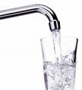
- Have soup for you meal, it as some fluids
- Make sure to count your servings or make
sure you use fluid items 8 times per day to get your servings in.

#31
Try adding sliced fruit to your water.

DISCUSSION:
We know that water is important for our bodies. Below are some ways to make the fluids we need more acceptable. It is fine to flavor the water you drink. However, it is important not to use too much sugar in the items picked. Try these below, the flavor may be acceptable.

SUPPLIES:
Water / Ice, cups, sliced fruit to be placed in water, excluding rind of fruit.

ACTIVITY:

- Pour water and ice into cup or container.
- Place sliced fruit into the water
- Shake to mix the flavors together
- Drink and enjoy
- Do not include the fruit skin or rind; this can make the drink bitter.

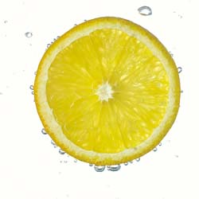
#32
Drink water at night to prevent late night snacks.

DISCUSSION:
Many people find it hard not to snack late at night before bed time and even in the middle of the night. This late night eating can cause weight gain, or unhealthy habits. Below is a suggestion to help keep people from snacking so late. See if this works for you, and if you can keep from eating lots of food at night!

ACTIVITY:

- During class discuss the subject of eating late.

- Determine if a majority of the class members snack late at night.

- It is important not to snack late at night. This can cause weight gain to occur.

- Figure out other ways to keep yourself from eating late at night. For example, try:
Doing puzzles

Working on the computer
Embroidering
Drawing pictures
Reading

- See how long you can go without eating too late at night. It’s a good habit to
complete !!

#33
Research number of calories spent exercising.

DISCUSSION:
It is fun to see how many calories might be used up during exercise!

Activity:
Here is an activity to see how your hard work at exercising can pay off.

- Decide on an activity you like to do and do it!
- Time yourself and see how many calories you use.
- Remember, the more active and hotter you get, the more calories you use up. Try out these activities slowly at first. See how long you can go the first time, then work harder the next time. Every time you work out you will be using a lot of calories !!

Good Luck !!

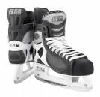

Calories Burned in 1 Hour of Exercise

http://www.calorie-counter.net/calories-exercise.htm

Here is a short approximate guide to the number of calories burned in an hour by each activity:

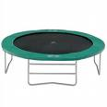

Sleeping - 60 calories
Eating - 85 calories
Sitting - 85 calories
Standing - 100 calories
Driving - 110 calories
Office (School) Work - 140 calories
Housework (moderate) - 160 calories
Golf (with trolley) - 180 calories
Gardening (light) - 250 calories
Walking, (3 mph) - 280 calories
Ping-Pong - 290 calories
Tennis - 400 calories
Roller-blading - 400 calories
Ice-Skating - 420 calories
Aerobics - 450 calories
Cycling (moderate) - 450 calories
Jogging (5 mph) - 500 calories
Swimming (vigorous) - 500 calories
Step Aerobics - 550 calories
Cycling (vigorous) - 600 calories
Walking (vigorous) - 600 calories
Skipping with rope - 700 calories
Running - 700 calories

Minutes of Exercise Required to Burn:
Note All figures are approximate. They are based on a 150 pound woman. If you weigh more, you will burn more calories.If you weigh less, you will burn fewer. http://www.annecollins.com/exercise-calories

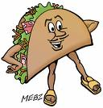
Mexican Fast Food
See chart below for the number of minutes of exercise required to burn off these foods
Exercise | Large Taco  x1 | Chimichanga  x 1 | Enchilada  x 1 | Tostada  x 1 | Burrito  x 2
Aerobics  Active | 71 | 58 | 42 | 29 | 66
Golf  With Trolley | 181 | 147 | 107 | 74 | 168
Dancing  Energetic | 82 | 67 | 49 | 34 | 76
Jogging  5mph | 66 | 53 | 39 | 27 | 61
Swimming  Steadily | 66 | 53 | 39 | 27 | 61
Walking  3mph | 110 | 89 | 65 | 45 | 102
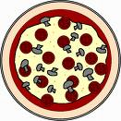

Pizza & Other Fast Food
See chart below for the number of minutes of exercise required to burn off these foods

Exercise | Pizza 12"  Cheese | Pizza 12"  Pepperoni | 1 Fried Sausage | Regular hot dog | Chicken Nuggets  x 6
Aerobics  Active | 117 | 143 | 13 | 31 | 39
Golf  With Trolley | 297 | 363 | 33 | 79 | 99
Dancing  Energetic | 135 | 165 | 15 | 36 | 45
Jogging  5mph | 108 | 132 | 12 | 28 | 36
Swimming  Steadily | 108 | 132 | 12 | 28 | 36
Walking  3mph | 180 | 220 | 20 | 48 | 60
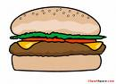

Hamburgers
See chart below for the number of minutes of exercise required to burn off these foods

Exercise | Cheeseburger and Fries | Lrge Hamburger and Fries | Fish and Chips | Chicken and Fries | 3 Pancakes with  butter & syrup
Aerobics  Active | 88 | 114 | 74 | 102 | 67
Golf  With Trolley | 224 | 290 | 188 | 260 | 171
Dancing  Energetic | 102 | 132 | 85 | 118 | 78
Jogging  5mph | 81 | 105 | 68 | 95 | 62
Swimming  Steadily | 81 | 105 | 68 | 95 | 62
Walking  3mph | 136 | 176 | 114 | 158 | 104

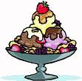

Fast Food Desserts
See chart below for the number of minutes of exercise required to burn off these foods

Exercise | Apple Pie | Brownie x 1 | Hot Fudge Sundae | Strawberry Shake | Ice-cream Cone  Large
Aerobics  Active | 34 | 32 | 38 | 47 | 44
Golf  With Trolley | 86 | 81 | 96 | 119 | 112
Dancing  Energetic | 39 | 37 | 43 | 54 | 51
Jogging  5mph | 31 | 29 | 35 | 43 | 41
Swimming  Steadily | 31 | 29 | 35 | 43 | 41
Walking  3mph | 52 | 49 | 58 | 72 | 68

#34
Burn calories doing chores around the house.

DISCUSSION:
You can burn a lot of fuel exercising, but you can also use up energy doing simple chores! It is fun to see how many calories you really can use up! Did you know that you can use 100 calories by cleaning for ½ hour or mowing the lawn for 17 minutes?

Activity:
Here is an activity to see how your hard work doing chores can pay off.

- Check which household chores you did last month.
- Write down how many minutes you spent doing it.
- Multiply the number of minutes by the calorie value of the chore to find the number of calories used to do your housework!

Housework Calorie Values per minute

- Making Beds 3.2 x _______ min = __________calories

- Washing Floors 3.8 x _______ min = __________calories

- Washing Windows 3.5 x _______ min = __________calories

- Dusting 2.2 x _______ min = __________calories

- Preparing a Meal 3.2 x _______ min = __________calories

- Shoveling Snow 6.5 x _______ min = __________calories

- Light Gardening 3.0 x _______ min = __________calories

- Weeding Garden 4.9 x _______ min = __________calories

- Mowing Grass with Power Mower 3.4 x _______ min = __________calories

- Mowing Grass with Manual Mower 3.8 x _______ min = __________calories

Note: For persons weighing 125-175 lbs.
http://www.lowfatlifestyle.com/calories.htm

#35
Don’t waste your time and money on diets/pills.

DISCUSSION:
“Fads” are things that come and go. Diets and diet pills are common “fads” that sometimes have bad health effects – especially for teens. Sometimes youth decide to do something like this because of pressure from friends or parents to be very slim. But not all teens need to lose weight. Instead of dieting because "everyone" is doing it or because you are not as thin as you want to be, you should first check with your doctor or nutritionist about your current body weight or “nutritional status”.

According to the FDA consumer in Sept 1993 (http://www.dietriot.com/fad/teenfad.htm), you can burn a lot of fuel exercising, but as with most everything else, there's a right way and a wrong way to lose weight. The wrong way is to skip meals, resolve to eat nothing but diet bread and water, take diet pills, or make yourself vomit. You may make it through the end of the week and maybe even lose a pound or two, but you're unlikely to keep the weight off for more than a few months--if that. And inducing vomiting can lead to an eating disorder called bulimia, which can result in serious health problems. (See "On the Teen Scene: Eating Disorders Require Medical Attention" in the March 1992 FDA Consumer.)

"The more you deprive yourself of the foods you love, the more you will crave those foods. Inevitably, you'll break down and binge," says Jo Ann Hattner, a clinical dietician at Packards Children's Hospital in Palo Alto, California. Then you'll not only gain those pounds back, you'll likely add a couple more.

Experts call this cycle of weight loss and weight gain "yo-yo" dieting, and believe that the repeated stress on your body of losing and gaining weight may be at least as bad for long-term health as being overweight.

Additionally, low-calorie diets that allow only a few types of foods can be bad for your health because they don't allow you to get enough vitamins and minerals. Kleinman warns that rapid weight loss from very-low-calorie "starvation diets" can cause serious effects in teenagers, such as gallstones, hair loss, weakness, and diarrhea.

As for diet pills, there is no magic pill that will “take it all away”. Diet pills are expensive and can be unsafe. Last year, FDA banned and recalled a number of products that were not proven to work or that posed serious health risks. Some products contained guar gum, which supposedly swelled in the stomach to provide a feeling of fullness. Unfortunately, the swelling from guar gum also caused blockages in the throat and stomach. There have also been other serious safety concerns with pills that have not been well studied.

Michael Weintraub, M.D., a consultant to FDA's Office of OTC Drug Evaluation, says "PPA is not recommended for use by teenagers because they are still growing and if they suppress their appetite, they may not get proper nutrition." The author of studies on PPA published in scientific journals, Weintraub adds, "This is especially true of teens who don't need to lose weight but think they do."

So, what should you do if you really need to get your body weight into shape? Believe it or not, it's as simple as making a few changes in your eating habits to emphasize healthy foods and exercise--good advice even if you don't need to lose weight.

A good diet is one that has balance, variety and moderation in food choices. "Balance your favorite foods which are usually high in fat with fruits and vegetables which are almost always low in fat; eat a wide variety of foods to keep from getting bored and to make sure your diet is nutritionally sound; and keep portion sizes reasonable so that you can have your [thin] slice of cake and lose weight, too." (Hattner)

Whether you are overweight or not, regular exercise (at least three times a week) is important to look and feel your best. If you do need to lose weight, stepping up your activity level will cause you to burn calories more quickly and make weight loss easier.

Fad or starvation diets and diet pills offer temporary solutions, at best. At worst, they may jeopardize your health. To lose weight and keep it off, your best bet is to reduce fat intake and to exercise.

Ruth Papazian is a writer in Bronx, N.Y.
FDA CONSUMER, September 1993

Activity:
Spend time as classmates discussing the concerns or questions that you have about what you just heard.

#36
Dine out less and eat more meals at home.

DISCUSSION:
More and more Americans are eating out instead of making meals at home. Add that to larger portions and popular menu choices that have been fried or prepared with fat, and people can easily walk away from a meal having consumed several more calories than originally estimated. Over time, this pattern may very well be responsible for the increase in overweight and obesity so evident today.

What can YOU do about that? Make the decision with your family to reduce the number of times you at out by ½ in one week. Then raise the bar to eating out every other week, then every two or three weeks! It takes some planning, but it’ll become a good habit for you and your entire family with your help!

ACTIVITY:
Take this quiz
Based on Robert Ebbin, Restaurants USA, November 2000
Q: How often do people eat out?

A: 1 in every 5 meals consumed by Americans is prepared in a commercial
setting. This averages 4.2 meals consumed per person per week. (Meal
Consumption Behavior — 2000, a new National Restaurant Association report.)

Q: Over the years, how much of an increase is that?
A: In 1981, the average was 3.7 meals consumed per person per week. Over the
years, the average annual consumption has increased by roughly 15 billion
meals since 1981 to now stand at an annual total of 38.4 billion meals consumed
outside of the home.

Q: Which meal is most likely to be commercially prepared?
A: Lunch. The typical person consumes an average of 2.1 commercially prepared
lunches per week.

Q: Who is more likely to eat out?
A: Individuals with higher household incomes are generally more likely than those
with lower incomes to dine out. Consumers with a household income of $75,000
or more eat an average of 4.9 commercially prepared meals per week, compared
with 3.2 meals for those with an income of less than $15,000.

#37
Learn about the calorie content of fast foods.

DISCUSSION:
If you have to eat out, you can learn about the calorie content of fast foods that you eat and pick healthier foods the next time you go. Remember, the best way to take care of your body is to modify what you eat and don’t eat.

ACTIVITY:
Complete the following chart and answer the following questions:
- What can you learn about the foods you normally eat?
- Compare your food choices and note where your calories are coming from (fat vs sugar).
- Is there a better option to eat at that place?
- How can you cut calories and fat at the same time?

Food Item | Amount | Calories | A better option?

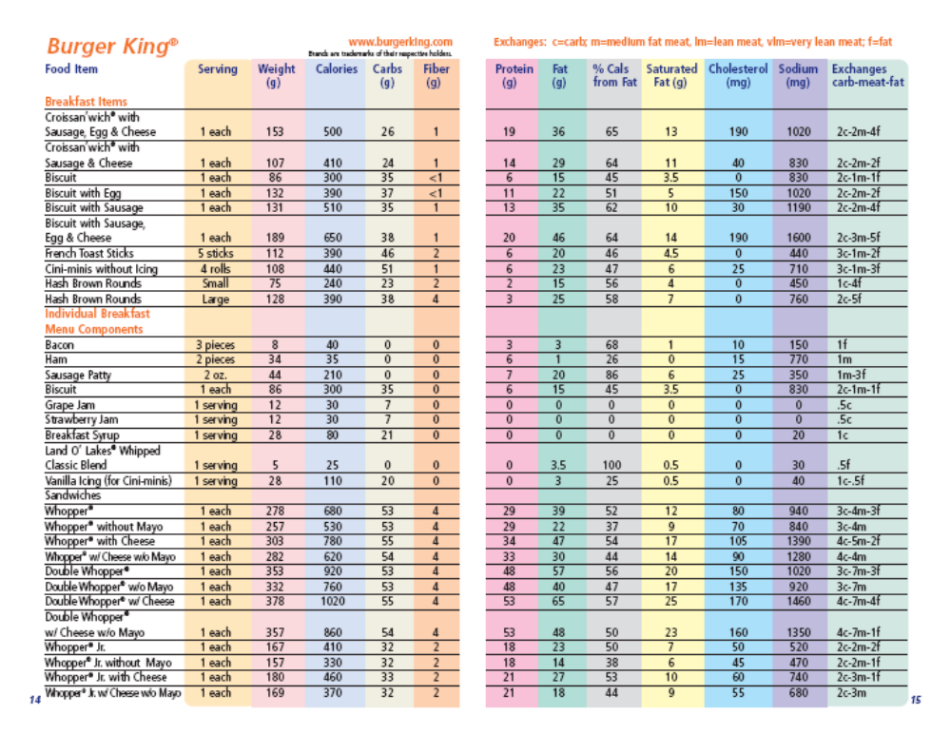
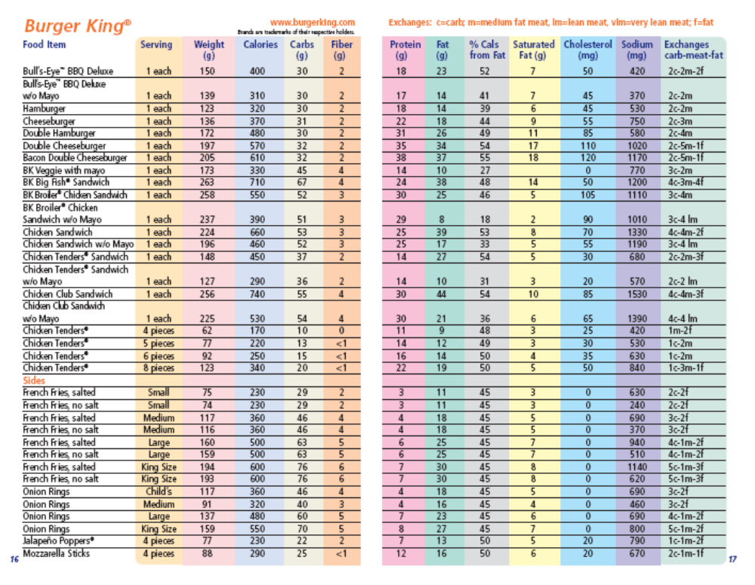
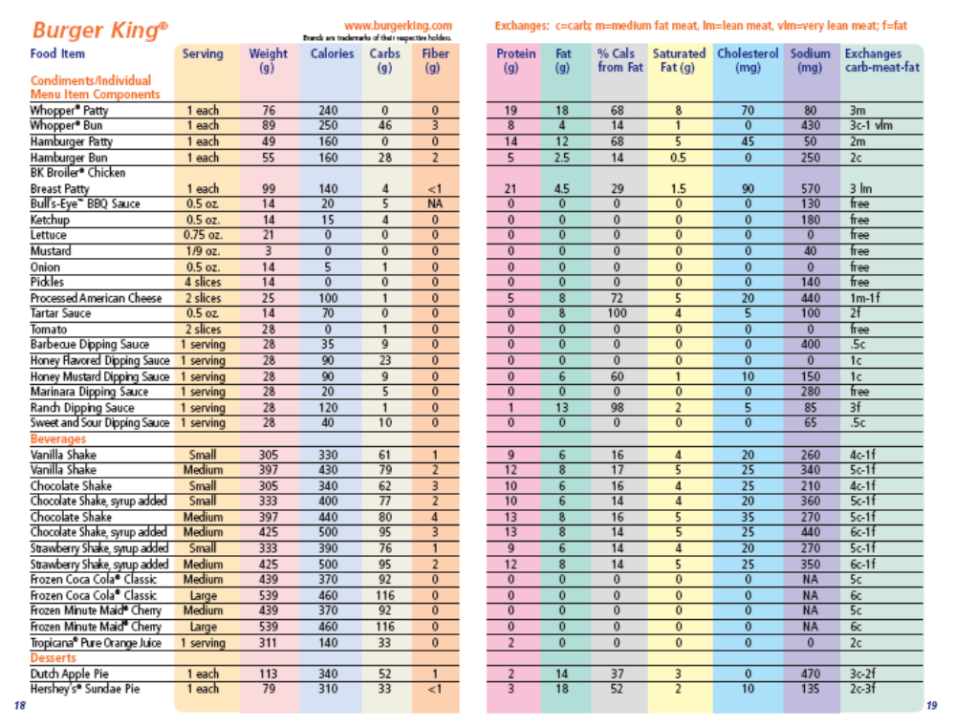
#38
See how much calories you can save with water.

DISCUSSION:
We all love to go out to eat and order beverages with our meals. However, many of those beverages are loaded with calories from sugar and/or fat. If you change the drinks you order to just plain water, you’ll be saving yourself unnecessary calories and money. The goal is to have a beverage containing less than 3-5 grams of fat/serving and less than 200 calories per drink.

ACTIVITY:
Complete the following chart and answer the following questions:
- What can you learn about the beverages you normally drink?
- Note where your calories are coming from (fat vs sugar).
- Is there a better beverage option to drink at that place?
- How can you cut calories and fat at the same time?

Beverage Item | Amount | Calories | A better option?

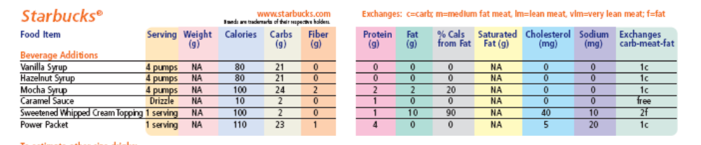
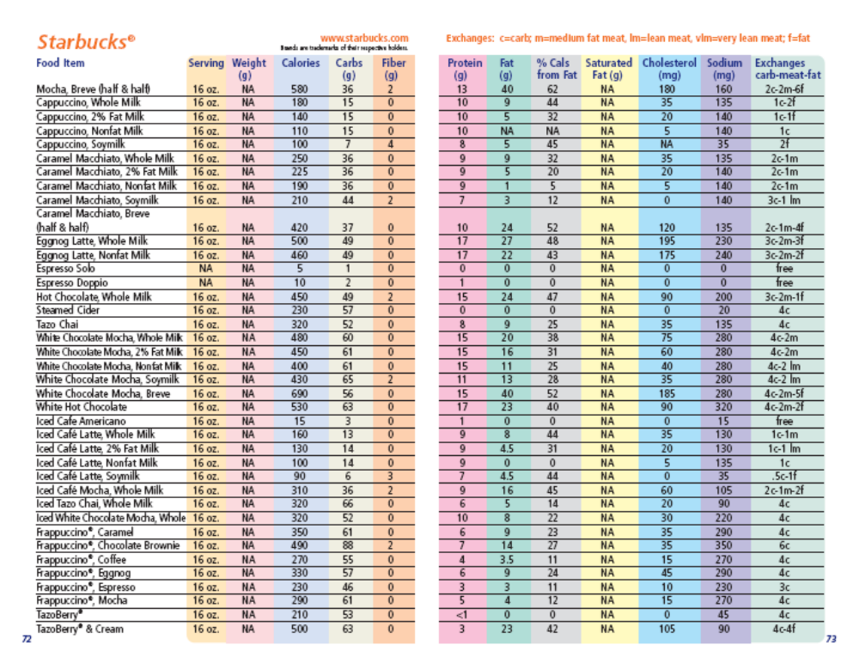
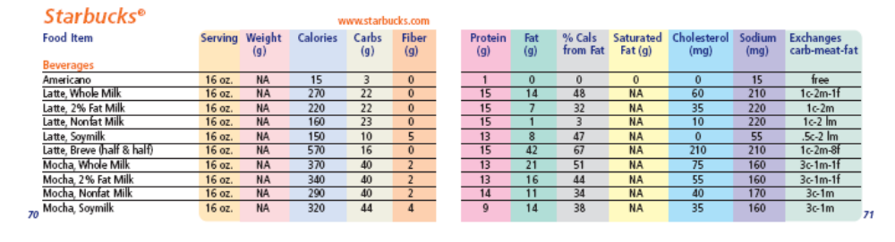
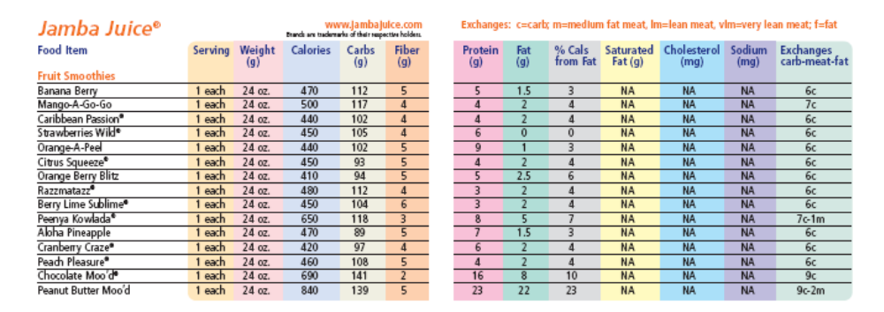
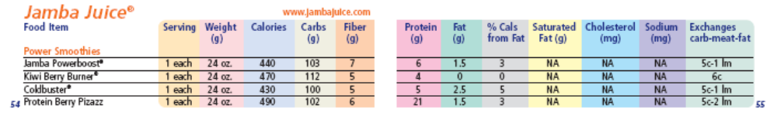
#39
Use the stairs in places like the mall.

DISCUSSION:

How many times do you go to the mall in one month? It’s a great place to be active while having fun! You say you only go up or downstairs very few times? No sweat. Mall walking is an easy way to work in fitness in any kind of weather! And you can even window shop at the same time!

ACTIVITY:
In the space provided, map out the major stores at your favorite mall from memory. Then, using the Sunday paper, map out all of the stores with sales and plan your window shopping route.

#40
Try dishing out smaller servings.

DISCUSSION:
One of the most important places to start maintaining your health is right on your plate. Studies show that people eat more when they’re served more. Possibly the easiest thing to do is dish out smaller servings and reduce the portion size of your meals. It is not as hard as it sounds. Once you begin eating smaller portions, a routine quickly sets in and it's easy to adapt.

ACTIVITY:
Do or mentally visualize doing the following:

STEP 1: Take a plate and portion out your usual portion.
STEP 2: Before eating anything, physically divide the food on your plate in half.
STEP 3: Go ahead and eat one half of your dish.
STEP 4: Put your fork down, sip some water, and see how hungry you really are.
STEP 5: If you are not hungry anymore, walk away and take notice of the portion
size that satisfied your appetite. Remember, you can always return to eat
a healthy snack if you become hungry later.
STEP 6: If you are still hungry, repeat Steps 2-5 with the remaining food on your
plate. Repeat as often as needed.

#41
When eating out, get a “kids’-size” meal.

DISCUSSION:
Today’s fast food places love to give us large portions of the items we ask for. Here is an idea to help us keep from eating too much. When eating out, get the kid’s meal, not the super size items. If you eat slowly, this will be plenty to hold you for a few hours, and by that time is over, it will be time to have a healthy snack. You still get the things you want, just in the smaller portion sizes that are really the right size for us to us.

ACTIVITY:
- Below list the fast food places you go to, and what might be on the kid’s meal.
- Determine if this is enough food for you meal.
- If the kid’s meal is not big enough, what would you buy to provide enough calories or food to keep your tummy happy until the next time to eat.

Restaurant | Items in Happy Meal | Other options to buy

#42
Chew gum instead of snacking between meals.

DISCUSSION:
Chewing a piece of gum can help reduce calorie intake, by being a diversion between meals and helping control the munchies. "Preliminary evidence suggests that chewing gum before a snack may reduce subsequent calorie intake," said Tom Wadden, PhD, the director of the University of Pennsylvania School of Medicine's Weight and Eating Disorders program and a member of the WSI Advisory Panel. In addition, research has shown that chewing gum appears to improve people's ability to retain and retrieve information. In fact, Michael Jordan often chewed gum during basketball games to better focus and concentrate (Wikipedia).


ACTIVITY:

Take the Bubble Gum Trivia Challenge
By T. Trimpe, 2001 (http://sciencespot.net/Media/bgumtrivia.pdf)

____ 1. How many sticks of gum does the average American chew in a year?

A. 200 B. 300 C. 400
____ 2. How many tons of gum are chewed every year?

A. 50,000 B. 75,000 C. 100,000
____ 3. San Luis Obispo, California, is the home of 'Bubble Gum Alley'. What is it?
A. An alley with brick walls covered with already-been-chewed gum wads.
B. The place where bubble gum was invented.
C. The home of the largest collection of bubble gum machines.
____ 4. Richard Walker holds the record for the Chomp Title by chewing 135 sticks of gum for the longest
time. How long did he chomp?

A. 5 hours B. 6 hours C. 8 hours
____ 5. The Topps company holds the record for having made the largest single piece of bubble gum. How
many pieces of normal-sized Bazooka did it equal?

A. 5000 B. 8000 C. 10, 000
____ 6. What is the Official Gum of Major League Baseball?

A. Bubble Yum B. Bazooka C. Topps
____ 7. Susan Mont"Gum"ery Williams is the Guinness Record Holder Of the Worlds Largest Gum Bubble.
How big was it?

A. 19 inches B. 23 Inches C. 27 inches

Answers: 1. B. 300; 2. C. 100,000; 3. A. An alley with brick walls covered with already-been-chewed gum wads; 4. C. 8 hours; 5. C. 10,000 (Topps presented the gum to baseball player Willie Mays in 1974. Mays then cut it into small chunks and gave it to children in nearby hospitals); 6. A. Bubble Yum; 7. B. 23 Inches

Many of the facts for the questions were found at Bubble Gum Fact page at http://mmwww.northville.k12.mi.us/STUDENTS/2005/dugganla/Hpage4.htm.
#43
Wait 20 minutes if you’re hungry before meals.

DISCUSSION:
Some people will snack between meals whether they are hungry or not. This can lead to a surplus of calories in your total day. If you’re hungry and it’s not mealtime, set a timer for 20 minutes. If you’re still hungry 20 minutes later, have a nutritious snack.

ACTIVITY:
20 minutes can stretch out to feel like a long time, but the time can pass alot faster if you keep busy doing something instead of thinking about food. Looking at the classroom clock, begin a 20 minute time period and see how many of the following activities you can accomplish in that time period. Hopefully, the time will pass quickly enough as you do just one or two of these activities!

- Read an article in a magazine or a chapter in a book.
- Sharpen your pencils.
- Clean and polish your shoes.
- Brush your hair and restyle it.
- Write a letter to a friend or relative.
- Do a homework assignment.
- Call a friend or relative.
- Answer email messages.
- Take a walk outside.
- Throw some hoops.
- Play a game.

#44
Craving something crunchy? Try vegetables.

DISCUSSION:
Before reaching for the chips to satisfy a “crunchy-food” craving, think about turning to vegetables, such as cucumbers, carrots, celery, and cauliflower. Vegetables are far more healthy – low in fat, calories, salt, and high in fiber – than any commercially prepared crunchy snack. So, give it a chance.

ACTIVITY:
List any vegetables that you like? Dislike? Have never tried and are willing to try?

LIKES DISLIKES WILLING TO TRY

.

.

.

.

#45
Craving something sweet? Try fruits.

DISCUSSION:
Before reaching for the candy to satisfy a “sweet-food” craving, think about turning to fruits, such as strawberries, grapes, apples, and bananas. Fruits are far more healthy – low in fat, calories, salt, and high in fiber – than any commercially prepared sweet snack. So, give it a chance.

ACTIVITY:
List any fruit that you like? Dislike? Have never tried and are willing to try?

LIKES DISLIKES WILLING TO TRY

.

.

.

.

#46
Wait 20 minutes before having a second helping.

DISCUSSION:
Hopefully, you are eating your meals slowly. But if you’re tempted to dish out seconds, stop and wait 20 minutes. This is about the time it takes for your body to know that your stomach is full. Then, if you are really hungry, go ahead and help yourself.

ACTIVITY:
20 minutes during a meal can seem like a long time to wait if you’re doing “nothin”. But it’s a great opportunity to connect to the friends and family with whom you are eating. Below are some conversation starters (flashcard style) to help pass the time away. Role play 4 of them in the classroom. Then, write down some of your own, as well, and use them at home with your family!

What was your high and low today? | Describe your dream vacation! | What is your favorite kind of music? | Who is someone you really respect? Why?
What freedom do you value the most? | Name a friend and why you like him/her. | What I like best about our family is….. | Tell about the last time you were late.
Would you rather (give two choices)…..? | How do you feel about (name a topic)….? | What is one food you dislike? | What is your favorite holiday and why?
How would you spend a $1000..00 gift? | Share something you always wanted to do. | What was the best day of the week? Why? | What makes you happy/sad?
Tell about someone who encourages you. | What is your favorite family tradition? | Make a list of your favorite movies. | Discuss how you can be of service to others.
What’s the best thing to do when angry? | Name some of your favorite foods. | Name some foods you dislike. | What did you learn today?
Flashcards adapted from: http://www.humec.ksu.edu/fnp/displays/mealtime/activities/conversation_cards.pdf
#47
Exercise for 60 minutes 3 times per week.

DISCUSSION:
When you exercise, you're helping build a strong body that will be able to move around and do all the stuff you need it to do. It is best to be active every day, but if you are busy or just starting out, a good goal would be to exercise 3 times per week for 60 minutes.
One of the best exercise types is “aerobic”, which means "with air." So, aerobic exercise is a kind of activity that requires oxygen and can get your heart pumping, make you sweat, and quicken your breathing. Doing this kind of workout on a regular basis will help your heart do its job.

ACTIVITY:
Find your pulse (at your neck or wrist) and count the number of times your heart beats in 10 seconds.
Now, try some aerobic exercise together right now!
- Skipping
- Hopscotch
- Jumping rope
- Jumping jacks
- Jogging in place (or walking quickly)
After you stop, recheck you pulse and see the difference in how your heart beats.

Other good exercises to try at home are:
- swimming
- basketball
- ice or roller hockey
- in-line skating, soccer
- skiing
- biking
- rowing

#48
Get enough sleep.

DISCUSSION:
Most kids between the ages of 5 and 12 need 10 to 11 hours of sleep each night. But most kids get only 9.5 hrs. "Why do I have to go to bed when I'm not even tired?” you ask. Sleep is more important than you may think. The average kid has a busy day. There's school, taking care of your pets, running around with friends, going to sports practice or other activities, and doing your homework. Phew! By the end of the day, your body needs a break. Sleep allows your body to rest for the next day. It also encourages growth. That's right, researchers believe too little sleep can affect growth and your immune system which keeps you from getting sick.
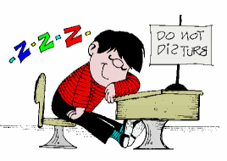
ACTIVITY:
Everything that's alive needs sleep to survive. Even your dog or cat curls up for naps. Animals sleep for the same reason you do - to give your body a tiny vacation. Choose which one needs more sleep - the kid or the animal. Remember, most kids (5-12) need 10-11 hours of sleep each night.

1. Lion or Kid? | Lion – needs 20 hours of sleep!
2. Adult or Kid? | Kid (adults only need 7 hours of sleep)
3. Chimpanzee or Kid? | Chimpanzee – needs 12 hours of sleep!
4. Pig or Kid? | Kid (pigs only need 8 hours of sleep)
5. Koala or Kid? | Koala – needs 18-20 hours of sleep!
6. Babies or Kid? | Babies – need 14-15 hours of sleep!
7. Cat or Kid? | Cat – needs 16 hours of sleep!
8. Mouse or Kid? | Mouse – needs 12 hours of sleep!
9. Elephant or Kid? | Kid (elephants only need 4-6 hours of sleep)
10. Giraffe or Kid? | Kid (giraffes only need 30 minutes sleep per day -- total!)
Adapted from Focus on food, http://www.kidshealth.org/kid/closet/games/bed_game.html
#49
Visit your doctor regularly to check your growth.

DISCUSSION:
Checkups allow your doctor to review your growth and development, perform tests, or receive shots. Checkups also are a good time to ask your doctor questions, like if you’re overweight, underweight, or just right. Make a list of your questions and concerns and bring it with you. The doctor will have answers to many questions, such as what you are eating and how you are sleeping. Some authorities recommend checkups at ages 2, 3, 4, 5, 6, 8, 10, 12, 14, 16, and 18 years.

ACTIVITY:
Spelling Bee -- How well can you spell health? Listen to each of the following words about health and see if you can spell them.
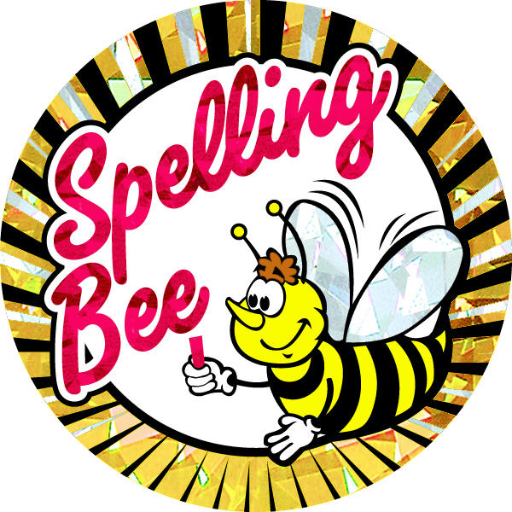
Vaccine
Insulin
Asthma
Antihistamine
Anesthesia
Chromosome

#50
Get to know the mighty muscles in your body.

DISCUSSION:
Did you know you have more than 600 muscles in your body? They help you do almost everything — from pumping blood throughout your body to lifting your heavy backpack. You control some of your muscles (skeletal) and others, like your heart, do their jobs without you thinking about them at all (smooth and cardiac). Muscles are all made of the same material, a type of elastic tissue (sort of like the material in a rubber band). Thousands, or even tens of thousands, of small fibers make up each muscle.

ACTIVITY:
Because there are so many skeletal muscles in your body, we can't list them all here. But here are a few of the major ones. Say the muscle name and move that part of the body as you learn about it. Discuss other ways to use that muscle in every day life:
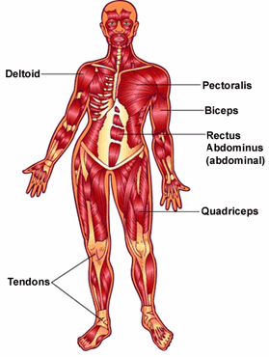
- In each of your shoulders is a deltoid (say: del-toyd) muscle. Your deltoid muscles help you move your shoulders every which way — from swinging a softball bat to shrugging your shoulders when you're not sure of an answer.
- The pectoralis (say: pek-tuh-rah-lus) muscles are found on each side of your upper chest. These are usually called pectorals (say: pek-tuh-rulz), or pecs, for short.
- Below these pectorals, down under your rib cage, are your rectus abdominus (say: rek-tus ab-dahm-uh-nus) muscles, or abdominals (say: ab-dahm-un-ulz).
- When you make a muscle in your arm, you tense your biceps (say: bye-seps) muscle. When you contract your biceps muscle, you can actually see it push up under your skin.
- Your quadriceps (say: kwad-ruh-seps), or quads, are the muscles on the front of your thighs. Many people who run, bike, or play sports develop large, strong quads.
- And when it's time for you to take a seat? You'll be sitting on your gluteus maximus (say: gloot-e-us mak-suh-mus), the muscle that's in your behind!

Focus on Food http://www.kidshealth.org/kid/closet/whatisit/food_game.html
#51
Did you know: 1 lb fat isn’t equal to 1 lb muscle?

DISCUSSION:
If you place 1 lb of muscle on a scale and 1 lb of fat on a scale, they will both weigh one pound. However, they will differ in sizes. While 1 lb of muscle is about the size of a baseball, 1 lb of fat will look like a large bowl of gelatin. Why? Muscle is a denser tissue and thus takes up less room than an equal weight of fat. And that’s okay, because having more muscle means you have a more desirable body composition, or fat-to-muscle ratio.
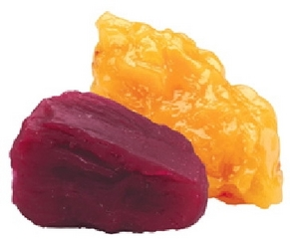
ACTIVITY:
Here are exercises that can help make your muscles stronger and build strength. Try doing a set of each together:
- push-ups
- pull-ups
- monkey swings
- tug-of-war

These are also good exercises to do at home to build muscles:
- rowing
- running
- in-line skating
- bike riding
#52
Appreciate your muscle-brain connection.

DISCUSSION:
How information is sent from the muscles to the brain. Your muscles are pretty good, but they can't detect small differences. This experiment shows "threshold detection" - a fancy name for the point at which your muscles can detect a enough of a weight difference to say to the brain: "Hey, this one is heavier!"

SUPPLIES:
A blindfold; Two large cups (16 oz. or greater); A marker; Enough marbles, beans, or rice to fill both cups; A friend or volunteer

ACTIVITY:
- Label one cup "A" and one cup "B."
- Fill each cup exactly halfway.
- Blindfold your friend or volunteer.
- Have your friend hold one cup in each hand. S/he should feel of equal weight.
- Take the cups back and add a small amount of marbles, beans, or rice to cup A. ("A" for add!)
- Return the cups to your friend's hands. Ask which weighs more.
- If your friend says one is heavier, ask which one. Is your friend right?
- If your friend says they weigh the same, take the cups back again and add a little more to cup A.
- Keep taking the cups back and adding to cup A until your friend notices a difference. When he or she does, how much extra weight was needed for the muscles to send that message to the brain?
Focus on Food (http://www.kidshealth.org/kid/closet/whatisit/food_game.html
#53
Learn how to read a food label.

DISCUSSION:
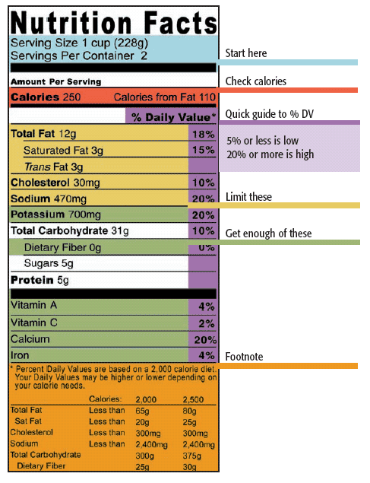
Everything we eat must now have a nutrition label on it. Food labels tell you all kinds of information about the nutrients in the food that you might find interesting. It also helps you make comparisons of different foods to find the best choice for you. If the item has come from out of a larger box, then the box will have the information on it. So, get hunting and see what kind of names you have come up with.

ACTIVITY:
Become familiar with reading food labels by comparing the following two examples and answering the questions:

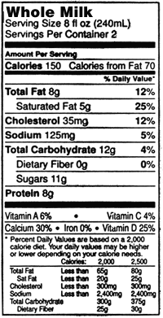
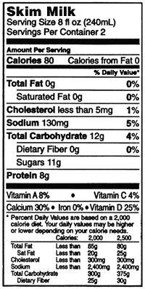
A B

- According to the label, how much is one serving? ___________
- Which one is higher in calories? ______________
- Which one is higher in fat? ______________
- How many grams of sodium is in each of the items? _________ and _________
- How much of this food does it take to make one serving of your own snack pack? ________________________
- If the doctor said to follow a low cholesterol diet, which one would be better for you? ____________
- Which nutrients are the same? _______________________________________
________________________________________________________________
- How many servings of this would you normally eat in one sitting? ____________
- Based on question 4, how many grams of fat would you be eating? ___________
- Based on question 4, how many grams of sugar would you be eating? ________
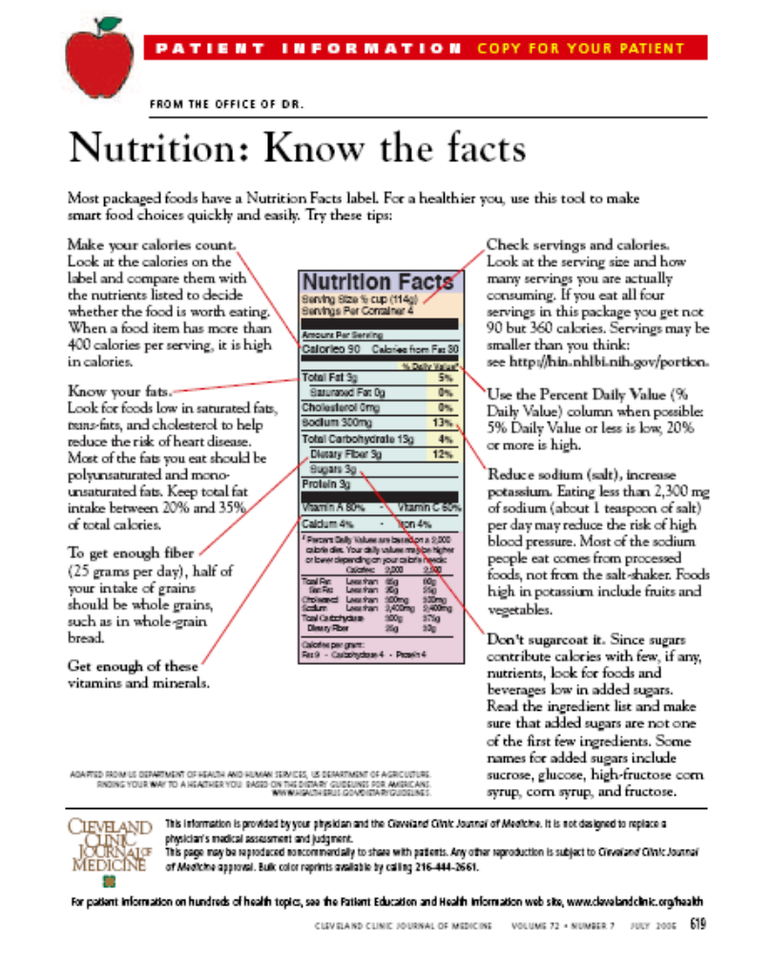
#54
If the label says “healthy”, it probably is.

DISCUSSION:
Approved health claims on a label have specific meanings, as defined by the government. To use the word “healthy” on its label, a food has to meet standards for salt, fat, and other nutrients.

ACTIVITY:
Review each definition carefully, and listen for the specifics of the term “healthy”.

FDA Specifications for Health Claims and Descriptive Terms
Claim | Requirements that must be met before using the claim in food labeling
Fat-Free | Less than 0.5 grams of fat per serving, with no added fat or oil
Low fat | 3 grams or less of fat per serving
Less fat | 25% or less fat than the comparison food
Saturated Fat Free | Less than 0.5 grams of saturated fat and 0.5 grams of trans-fatty acids per serving
Cholesterol-Free | Less than 2 mg cholesterol per serving, and 2 grams or less saturated fat per serving
Low Cholesterol | 20 mg or less cholesterol per serving and 2 grams or less saturated fat per serving
Reduced Calorie | At least 25% fewer calories per serving than the comparison food
Low Calorie | 40 calories or less per serving
Extra Lean | Less than 5 grams of fat, 2 grams of saturated fat, and 95 mg of cholesterol per (100 gram) serving of meat, poultry or seafood
Lean | Less than 10 grams of fat, 4.5 g of saturated fat, and 95 mg of cholesterol per (100 gram) serving of meat, poultry or seafood
Light (fat) | 50% or less of fat than in the comparison food (ex: 50% less fat than our regular cheese)
Light (calories) | 1/3 fewer calories than the comparison food
High-Fiber | 5 grams or more fiber per serving
Sugar-Free | Less than 0.5 grams of sugar per serving
Sodium-Free  or Salt-Free | Less than 5 mg of sodium per serving
Low Sodium | 140 mg or less per serving
Very Low Sodium | 35 mg or less per serving
Healthy | A food low in fat, saturated fat, cholesterol and sodium, and contains at least 10% of the Daily Values for vitamin A, vitamin C, iron, calcium, protein or fiber.
"High", "Rich in" or "Excellent Source" | 20% or more of the Daily Value for a given nutrient per serving
"Less", "Fewer" or  "Reduced" | At least 25% less of a given nutrient or calories than the comparison food
"Low", "Little", "Few", or "Low Source of" | An amount that would allow frequent consumption of the food without exceeding the Daily Value for the nutrient - but can only make the claim as it applies to all similar foods
"Good Source Of", "More", or "Added" | The food provides 10% more of the Daily Value for a given nutrient than the comparison food
#55
Research the ingredients on the food labels.

DISCUSSION:
The ingredients list tells you, usually in fine print, what ingredients the food contains. These are listed in order, starting with the ingredient found in the largest amount, by weight, and progressing to the ingredient present in the smallest amount. The ingredients list also helps to identify items that may cause food allergies or have adverse effects. Here you can find out if a food contains eggs, soy, milk, corn, or whatever you must avoid eating. It's important, even critical, to know the lingo. Casein, caseinate, lactalbumin, whey or whey solids are all derived from cow's milk, though their names don't reveal this. Albumin comes from eggs. Dextrose and glucose may originate in corn. Hydrolyzed vegetable protein starts with soybeans, and some of the products used to thicken or stabilize food texture, such as acacia gum, are legume products.

SUPPLIES:
Labels from cracker boxes, soup cans, cookies; Food label handout .

ACTIVITY:
- Choose a food with label.

- Write down the top 5 ingredients on the label below:
________________________________________________________________________________________________________________________________________________________________________________________________________________________________________________________________________________________________________________________________

- Look at your list of ingredients provided

- Write the definition of your ingredients below
________________________________________________________________________________________________________________________________________________________________________________________________________________________________________________________________
________________________________________________________________

- Do these items sound Healthy? Why or why not?

Labelling Term Dictionary
http://web.ncf.ca/ed205/labels.htm

Acetic acid: vinegar added to food to produce a higher acid level, to flavor and to preserve.
Agar: a non-digestible, odorless carbohydrate made from seaweed, used as a thickener in ice cream, jams and whipped toppings.
Alginate: (propylene glycol alginate) a thickening agent made from seaweed used to maintain the texture of candy, cheese, ice cream, whipped toppings and other non acidic foods.
Alpha Tocopherol: (vitamin E) added to foods high in fat and oils to avoid them from going rancid.
Amylases: enzymes in cereal that convert starch into sugars to produce a sweeter flavour.
Ascorbic Acid: (vitamin C) added to fruit and their juices to maintain colour and flavour. Nutritional Value
Ascorbyl Palmitate: a fat soluble chemical form of ascorbic acid, a preservative in high fatty foods.
Azodicarbonamide: a maturing agent used in flour.
Benzolyl Peroxide: an agent used to bleach flour, usually used with a maturing agent.
Beta Carotene: a forerunner of vitamin A, yellow color and is used for nutrition or as a coloring agent.
Butylated Hydroxyanisole: (BHA) and butylated hydroxytoluene (BHT) are used in products with fat and oil to increase shelf life.
Calcium Phosphates: added to foods for a source of calcium, phosphorus and used as a preservative.
Calcium Propionate: chemicals used in baked good to prevent bacteria growth and molding.
Carrageenan: a stabilizer or thickening agent made from a type of seaweed, used in commercially prepared milk, desserts, ready to feed baby formula and processed poultry, when used in poultry it is also known as: seasoning or pump.
Chlorine: (ClO2) and chlorine dioxide (Cl2) are gases used to age flour.
Citric Acid: it is the substance that gives citric fruit its acid flavor.
Cysteine: an amino acid (protein component) which occurs naturally or is added to foods to prevent oxygen from destroying vitamin C, also improves the quality of doughs.
Dextrin: a breakdown product of starch used as a thickener or to prevent crystallization in foods.
Dextrose: (glucose) a sugar, not as sweet as table sugar.
Diethylptrocarbonate: (DEPC) prevents the growth of micro-organisms in soft drinks.
Dioctylsodium Sulfo-succinate: added to powdered products to help dissolve in water.
Disodium Guanylate: (GMP), and disodium inosinate (IMP) are flavor enhancers.
Ethylenediaminetetraacetate: (EDTA) or (disodium EDTA), prevents rancidity in fats, discoloration of fruits/vegetables and traps minute metal particles which may have contaminated the product.
Ergosterol: (vitamin D) a natural product in yeast and mold, converted to vit D by altra violet irradiation.
Ferrous Gluconate: a source of iron in fortified foods/vitamin supplements, used to color black olives
Fumaric Acid: added to food to produce a tart flavor.
Glycerine: (glycerol) used as a moisturizer, to prevent candies from becomming hard or dried out.
Glycine: (aminoactic acid) an amino acid (part of protein) added to soft drinks as an artificial sweetener and to lessen the bitter after-taste of saccharine
Guar Gum: and gum arabic (acacia gum), are vegetable gums widely used as thickeners and stabilizers.
Hydrolyzed Vegetable Protein: (HVP) vegetable protein acts like flavour enhancers.
Hydroxylated lecithin: an emulsifier and stabilizer used in baked goods, margarine, and ice cream, it is formed by treating lecithin with a peroxide.
Imitation Beef Flavor: and imitation chicken flavor, containing hydrolyzed vegetable protein, monosodium glutamate, sugars, vegetable fat, amino acids, disodium inosinate, modified starch, and (disodium guanylate in chicken only).
Lactose: sugar from milk, used with lower sweetness products, has 1/6th the sweetening power of sugar.
Lecithin: an emulsifier added to foods to prevent the sepaqration of fats from water.
Malic Acid: gives a tart flavor to fruit based foods.
Malt Flour: a dried, milled germinated wheat or barley, it contains enzymes that digest the starch to produce sugars (maltose and glucose), it increases sweetness and solubility in foods.
Mannitol: used as a sweetener in low calorie food products.
Modified Starch: a starch treated physically or chemically to change gel power, color, clarity or stability.
Mono and Diglycerides: are added to foods with a high fat content to stabilize the texture.
Pectin: added to jams and jellies to form a natural gel.
Polusorbate (60) (65) (80): emulsifier added to many foods to avoid fat and water from separating.
Potassium Bromate: added to age the flour and improve baking quality.
Potassium Iodide: is a nutrient required in the diet to prevent goiter, it is added to table salt, other sources of iodine are: Cuprous Iodide or Calcium Iodide.
Potassium or Calcium Iodate: conditioning agents added to flour to improve baking quality.
Propyl Gallate: added to fats and oils often along with BHT or BHA to prevent it from becoming rancid.
Propylene Glycol: and fatty acid esters are added to foods to maintain moisture content and to carry flavouring substances.
Riboflavin(vitamin B2): needed for the metabolism of protein.
Saccharin: artificial sweetener added to calerie reduced foods, it has the sweetening power of 300 to 500 times of sugar with no caloric value.
Silicone Dixoide: added to dry ingredients to maintain dryness and prevent caking.
Sodium Benzoate: a preservative added to acidic foods to kill bacteria, also known as: benzoate of sodium or benzoic acid .
Sodium Iron Pyrophosphate: source of iron. Nutritional value
Sodium Nitrate or Sodium Nitrite: a preservative added to precessed or cured meats to kill bacteria and enhance the colour, the amount permitted in foods are resticted by law.
Sorbic Acid: added to acidic foods to prevent the growth of molds and fungus, also known as: calcium, sodium or potassium sorbate.
Sorbitan Monostearate: an emulsifier added to candies and dessert products to stabilize fat.
Sorbitol: a sugar type sweetener with almost 2/3: the sweetening power of sugar, it is absorbed slowlty into the system therfore used mostly in diabetic food products.
Sulphur Dioxide: a preservative used in foods (mainly fruits and wines) to prevent dis-colouration, also known as: sodium bisulfate.
Tannin or Tannic Acid: found in teas, coffee and cocoa, it can be added to foods as an ingredient or an artificial flavour.
Textured Vegetable Protein (TVP): soy protein used as a replacement or addative to ground meat, also known as: isolated soy protein.
Thiamin: (vitamin B3) needed for the normal metabolism of carbohydrates. Nutritional value
Vanillin: synthetic flavours extracted from the bean of the vanilla plant, also known as: ethyl vanillin, vanilla.

#56
Pick something with fewer preservatives.

DISCUSSION:
Since we are learning about the food labels of the food we eat, now is the time to actually use what we have learned and actually read the labels.

ACTIVITY:
Take this worksheet with you to the grocery store (or instructor gather samples of food labels) and look at some labels. See if you can understand the labels well.

  - Review the handout on label ingredients (see previous lesson).
  - Think about the items your family buys at the grocery store and write them down
on this page.
  - Take this list to the grocery store with you and research the labels on the items.
  - List the top 5 ingredients on this page.
  - Can you think of items that would be a better substitute for the items listed here?

______________________________________________________________________
______________________________________________________________________
______________________________________________________________________
______________________________________________________________________
______________________________________________________________________
______________________________________________________________________
______________________________________________________________________
______________________________________________________________________
______________________________________________________________________
______________________________________________________________________
______________________________________________________________________
______________________________________________________________________
#57
Drink fruit juice that is 100% juice.

DISCUSSION:
Fruit juice is a quick way to get calories and sugar. However, some juices are really better than others. Look for juices that have 100% real fruit juice, and remember to read the ingredient list. The first item listed is in the greatest amount. Most fruit juices have corn syrup as the first item, except those that are 100% fruit juice.

ACTIVITY:

Answer the following:

- Think about what kind of fruit juice your family purchases at the grocery store.
- List them here if you know .___________________________________________
- Review the list of fruit juices provided. Is your juice on that? ________________
- After learning about juices, do you think you should continue buying it? ________
- Why do you think it is better to buy the 100% juice? _________________________________
_______________________________________
- Go to the grocery store and see if your family can purchase the 100% juice.
- After you taste the juice, does it taste better? ____________________________

Benefits of a Diet Rich in Juice Blends
By Carol A. Savage, M.S., R.D.
What are the health benefits of a diet including fruits and vegetables?
Fruits and vegetables are key components of a healthy diet as they provide a variety of nutrients needed on a daily basis, are naturally low in fat and calories and contain no cholesterol. In addition, a diet rich in fruits and vegetables protects from chronic diseases and enables optimal growth and development.
Juice made from fruits and vegetables is a great way to contribute to your child’s daily servings of fruits and vegetables. But not just any bottle will do. When choosing a juice, read the Nutrition Facts panels to make sure you are buying a 100% fruit juice or 100% vegetable juice and not a “juice cocktail” or “juice beverage”. These choices do not contain 100% juice. All Nestlé Juicy Juice flavors are 100% juice.
The serving size for children 4-6 yrs of age, based on the MyPyramid for fruit and vegetable juice, is ½ cup (4 oz.). The Food Pyramid recommends 8 servings of fruits and vegetables per day, which means your children should be eating a minimum of 3 servings of fruits and 5 servings of vegetables daily. Unfortunately many young children are not getting the 8 servings of grapes and apples, sweet potatoes and carrots and all those other good things they need. How can you help? Plan to have a variety of fruits and vegetables readily available for meals and snacking. Fill a fruit bowl with polished green apples. Set out a plate of fresh strawberries with breakfast. Tuck a peach or plum in your child’s lunchbox. By making fruits and vegetables a part of every meal and snack and you can easily provide the 8 servings recommended per day.

Carol Savage is a Registered Dietitian with a Masters Degree in Nutrition. She has a strong background in infant and pediatric nutrition including work in public health and with the USDA’s Food and Nutrition programs.
http://www.juicyjuice.com/harvestsurprise/articles/ArticleDetails.aspx?ArticleId=95F3DD40-BA7E-4705-8964-4620EDE0B7CC#Bottom of Form 1
#58
Choose a snack that requires some effort.

DISCUSSION:
Ninety percent of American have a snack at least once a day, and 63% of us feel conflicted about our choices. Depending on your choice, a snack can be healthy or unhealthy for your body. If you’ve decided that you’re going to have a snack, consider choosing a snack that requires some effort, like popped popcorn, or an orange that requires peeling, or a food that requires advance preparation. The thought of not receiving instant gratification for your snack craving might serve to convince your mind and body that you really don’t need a snack.

ACTIVITY:
What Kind Of Snacker Are You? By Carolyn Magner Mason (http://www.webmd.com/content/article/58/66577.htm)

1. Your favorite snack:
- makes you feel guilty.
- is a candy bar and a diet drink.
- requires an extra workout.
- gives you a lot of pleasure.
- is a fruit or a vegetable.
2. When choosing your snack, you:
- look around to see who's watching you sneak a donut.
- use artifical sweetener in your coffee to make up for the Krispy Kreme donut.
- substitute breakfast for your late-morning donut.
- happily eat your donut in front of your coworkers.
- skip the donut for a celery stick.
3. You are bored and there's nothing on TV. You:
- defrost the candy bar hidden in the freezer.
- fix sugarless hot chocolate and load it with marshmallows.
- make a bowl of ice cream and chocolate syrup, then jump rope for 30 minutes.
- break open a bag of potato chips and eat the whole bag.
- slice an apple and top it with fat-free yogurt.
If you chose mostly A's, you are a "Conflicted Snacker." You feel guilty about snacking and try to avoid it when you can.
If you chose mostly B's, you are a "Contradictory Snacker," and will attempt to balance an unhealthy snack with a healthy one.
If you chose mostly C's, you are a "Disciplinary Snacker" and you punish yourself for snacking by skipping a meal or adding an extra work out.
If you chose mostly D's, you are a "Shameless Snacker" and figure the heck with diets, bring on the snacks.
If you chose mostly E's, you are "Healthy Snacker". Congratulations.
#59
Stay positive about your changing habits.

DISCUSSION:
Stay positive about your changing dietary habits. It takes about 6 months to feel like you have changed the habit for good. Many people say that it takes a long time to continue a change. Think about the changes you have hopefully made in the past for better eating. Be proud of your changes. Keep them up and pat yourself on your back.

ACTIVITY:
Discuss what you have done lately to eat healthy. Is it eating better items, drinking more water, trying new things. List them below:
____________________________________________________________________________________________________________________________________________________________________________________________________________

How long have you been doing this? _______

If you have not done anything positive for your intake, what are you willing to do?
__________________________________________________________________________________________________________________________________________________________________________________________________________________

Discuss in class and with your family.
#60
Measure the amount of sugar in foods.

DISCUSSION:
Common measurements to know about sugar:
1 tsp of sugar = 4 grams of sugar
1 Tbsp of sugar = 12 grams of sugar

ACTIVITY:
- Review the measurements above.
- Look at the labels of your favorite candy or dessert.
- Determine how many grams of sugar is in each item.
- Using a measuring spoon and granulated sugar, measure out the amount of sugar in these items by placing the measured sugar into a plastic bag. Is there a lot of sugar in them? Is this good for you?
- Repeat this activity with different foods that you commonly eat.

#61
Learn how much sugar a can of soda has.

DISCUSSION:
Soda’s have a lot of sugar and preservatives in them. In fact, that’s really all they are made of. The only thing that might be good in them is the small amount of fluid. After learning just how much sugar is in soda, you might decide that water is a better choice of beverage.
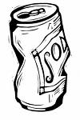
Common measurements to know about sugar:
1 tsp of sugar = 4 grams of sugar
1 Tbsp of sugar = 12 grams of sugar

ACTIVITY:
Part 1
- Review the measurements above.
- Look at the labels of your favorite soda or fruit drink.
- Determine how many grams of sugar is in each item. If a 12 oz can has 40 grams of sugar, how many teaspoons of sugar are in that can of soda? _____________
- Using a measuring spoon and granulated sugar, measure out the amount of sugar in these items by placing the measured sugar into a plastic bag. Is there a lot of sugar in them? Is this good for you?
- Repeat this activity with different beverages that you like to drink.

Part 2:
- Think of how many soda’s you drink in a day or a week. ___________________
- Review the measurements above.
- Multiply the calories and the sugar content by the number of soda’s you consume.
____________________________
- Is that a healthy number of calories and sugar? _________________________________
- What would you be willing to drink to help reduce these numbers?
_________________________________________________________

#62
Learn the basics about how your body works.

DISCUSSION:

Something as basic as understanding how your body works can help you learn how to keep it healthy. Body hygiene, stress, nutrition, digestion, and body changes are just some of the many factors that go into how well you grow and develop.

ACTIVITY:

Question: How many bones does a grown person have?

Answer: 206

Question: Which part of your digestive system is like a mixer?

Answer: The stomach

Question: What juice from your liver helps to absorb fats in the bloodstream?

Answer: Bile

Question: If you weigh 80 pounds, about how much of your weight is muscle?

Answer: About 40 pounds, or 1/2 of your weight

Question: How much longer will your hair be in 1 month if you don't get a haircut?

Now, figure out how long it would take for your hair to grow 3 feet.

Answer: Your hair will grow about 1/2 inch in a month. It will take 72 months (6

years) for it to grow 3 feet!

Question: Where can you find your pulse?

Answer: Anywhere an artery comes close to the surface of your skin, such as the

inside of your wrist (just below your thumb) or the side of your neck

Question: How fast is a sneeze?

Answer: 100 miles per hour

Question: What happens to your skin to make it wrinkled and soggy in water?
Answer: Your skin gets pruney when it absorbs water. If you stay in the water for a
long time, your protective layer of sebum and sweat get washed away,
allowing the water to get through.

#63
Appreciate your tongue.

DISCUSSION:
Your tongue is made up of many groups of muscles. These muscles run in different directions to carry out all the tongue's jobs. The back of your tongue is especialy important for eating. Once the food is all ground up and mixed with saliva, or spit, the back muscles start to work. They move and push a small bit of food along with saliva into your esophagus (say: ih-sah-fuh-gus), which is a food pipe that leads from your throat to your stomach.

Your tongue is covered with a layer of bumps called papillae (say: puh-pih-luh).
Papillae help grip food and move it around while you chew. And they contain your taste buds, so you can taste everything from apples to zucchini! People are born with about 10,000 taste buds. But as a person ages, some of his or her taste buds die. (An old person may only have 5,000 taste buds!) That's why some foods may taste stronger to you than they do to an adult. Taste buds can detect sweet, sour, bitter, and salty flavors.

Saliva is also a friend of the tongue. A dry tongue can't taste a thing, so saliva helps the tongue by keeping it wet. Saliva moistens food and helps to break it down, which makes it easier for the tongue to push the food back to swallow it.

SUPPLIES:

Paper towels; Foods to taste (cookies, crackers, pretzels, or other dry food); Drinking water for everyone; A friend or volunteer.

ACTIVITY:
Why do we need saliva to taste foods? In order for food to have taste, chemicals from the food must first dissolve in saliva. Once dissolved, the chemicals can be detected by receptors on taste buds. Try this experiment:
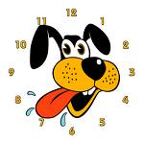
- Use a clean paper towel to dry off your tongue.
- Taste each food, one by one. How does it taste?
- Have a drink of water.
- Taste each food again, letting your saliva do its magic!

Adapted from Focus on Food, http://www.kidshealth.org/kid/misc/focus_watermelon.html

#64
Fruit and vegetables are ideal snacks.

DISCUSSION:
Fruit and vegetables are inexpensive and ideal snacks. Not only are they quick and easy, but they tastes good, too. There are so many to choose!

ACTIVITY:
Guess the fruit:
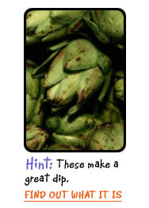
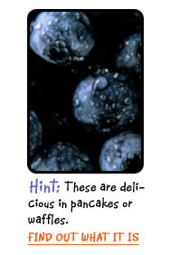
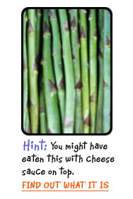
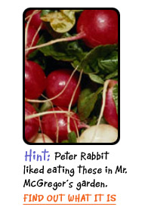
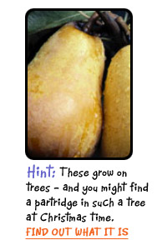
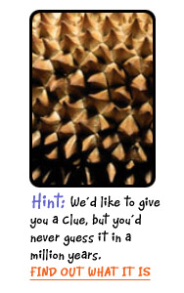
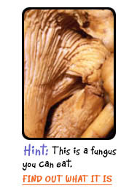
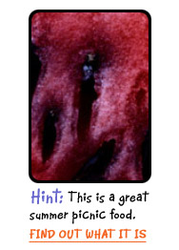

Answers:

WATERMELON  Watermelon is a juicy, pink fruit that's 92% water.  How do you eat it?  You eat it raw and it's refreshing served cold. Farmers suggest scooping some out to freeze. Enjoy the scoop on an ice cream cone or a paper cone. | ARTICHOKE  Artichokes are in the same plant family as sunflowers.  How do you eat it  The part people eat is actually a bud of the plant. They're usually steamed, boiled, or microwaved. Baby artichokes also can be sauteed or stir-fried. | MUSHROOM  Mushrooms are fungi which means more than one fungus.  How do you eat it  Mushrooms can be eaten raw or cooked. Try them on your salad, your pizza, in your soup, or your Chinese meal. | BLUEBERRIES  Blueberries are small berries that grow on bushes.  How do you eat it  They can be eaten raw as a snack, as part of a fruit salad, or even as a topping for yogurt or ice cream.
PEARS  Pears are sweet and mellow fruits that come in several colors, including green, yellow, red, and brown.  How do you eat it  Pears are great raw or cooked, like in desserts or jams. Try some raw pear slices with a slice of Swiss cheese. | RADISHES  Radishes are root vegetables, which means the part you eat grows underground.  How do you eat it  Red radishes can be eaten raw in salads, sandwiches, or with dips. Other varieties of radishes are usually cooked, which mellows their peppery bite. | ASPARAGUS  Asparagus is a green vegetable that grows in spears.  How do you eat it  You can try it raw, but it's usually cooked in a little boiling water, steamed, baked in a hot oven, or stir-fried in a pan. Another way is to brush it with olive oil and grill it. | DURIAN  This thorny fruit grows on tall trees and is very popular in Asia.  How do you eat it  Inside is a substance like sticky custard or soft cheese. If you try durian, you might want to hold your nose.  It's often eaten with rice or used to flavor ice cream
Adapted from Focus on Food, http://www.kidshealth.org/kid/misc/focus_watermelon.html

#65
Pat yourself on the back for trying a new habit.

DISCUSSION:
After making goals for change and actually doing them, it’s important to celebrate your success! Some rewards can be permanent reminders of what you have accomplished. Others can be fun enjoyment to mark milestones of accomplishments in your physical and behavioral changes. Maybe you actually exercise 5 days a week now with your family or perhaps you’ve not watched television for 2 whole weeks! No matter how small or large the achievement, if it was important to you, then it is a big deal. So, pat yourself on the back for doing something!

ACTIVITY:
Your goals were personal, so your rewards should be uniquely “you” as well. Below are some examples of reward ideas. Think of ways to celebrate your accomplishments that are both small and large and write them down. They don’t always have to be “things”, but it can also be doing something simple that you enjoy or have never done before!

Sample goal: I will walk 30 minutes 5 days this week.
Reward ideas: For every day I walk, I will “pay myself” $3. After every week I walk
5 days, I will download a favorite song of mine with the money.

Sample goal: I will drink water instead of soda.
Reward ideas: Take a bubble bath or sleep in on Sunday or read a new book or
phone a distant friend or get a haircut or buy a new pair of
sneakers, etc
Your ideas:

.

.

.

.

.

.
#66
Boost your fiber intake.

DISCUSSION:
Dietary fiber is part of all plant foods and helps promote regular bowel movements. Fiber is also valuable for school-aged children, mainly because it delays the absorption of sugars from the food into the bloodstream, making the blood sugars more stable.

ACTIVITY:
Calculate how much fiber you need by following this formula:

Age of child in years plus five = grams of fiber for you each day.

Memorize these two fiber rules:

The 4 A's of Fiber
Remember the four A's of fiber: apples, artichokes, apricots, and avocados.

The 3 B's of Fiber
Remember the three B's of fiber: bran, beans, and berries. One serving of bran plus one serving of beans each day will give you over half your total daily fiber needs. And remember: bran and berries blend well into yogurt smoothies.

#67
Cut down on TV/screen time and get moving!

DISCUSSION:
The National Institute on Media and the Family reported that children, ages 8 to 18, spend more time (44.5 hours per week) in front of computer, television, and game screens than any other activity in their lives except sleeping (Kaiser Family Foundation, 2005). Another study found that children who watch more than three hours of television a day are 50 per cent more likely to be obese than kids who watch fewer than two hours. These researchers conclude that "more than 60% of overweight incidents can be linked to excess TV viewing" (Tremblay, 2003).

So many studies have found a corresponding trend in weight gain and TV and/or screen time. Because of this concern, the American Academy of Pediatrics (AAP) recommends that kids under age 2 have no screen time, and that kids older than 2 watch no more than 1 to 2 hours a day of quality programming.

ACTIVITY:
Take the No-Screen-Time Challenge and Get Moving!!

- Count how many hours you watch TV or play video games during the week. ______

- How can some of this time or most of the time, be used for exercise? _________________________________________________
- Commit to spending one week without any TV or screen time!
- Plan a replacement activities (like taking walks)
.
.
.
. _____
- Inform your parent/family and friends of your decision.
- Set personal rewards to celebrate daily milestones and a weekly achievement.
- Track your daily success in the chart below.
- Write down your feelings along the journey and share with classmates.

SUN | MON | TUES | WED | THURS | FRI | SAT
Y N | Y N | Y N | Y N | Y N | Y N | Y N

#68
Be aware of the media’s influence on you.

DISCUSSION:
TV is a very powerful tool. However, TV can direct us into doing or eating things that are not healthy for us. It would be interesting to see how many commercials one can see in a 1 hour period of watching TV. Below are instructions for counting commercials. It’s easy to see what commercials encourage healthy things or junk food.

ACTIVITY:
The next time you watch any TV, list the commercials suggesting junk food, candy, etc.

Identify the product or company.
____________________ ____________________

____________________ ____________________

____________________ ____________________

____________________ ____________________

____________________ ____________________

Total time watched: _________________________

Number of commercials: _____________________

How many are healthy items? _________________

How many were unhealthy items? ______________

Share your findings with the class and discuss the following:

- Why do they try to sell the unhealthy items?
- Can you try to buy healthier items Instead?
- Why or why not.__________________________

#69
Take care of your teeth.

DISCUSSION:
A cavity is a hole in your teeth that can grow bigger and deeper over time when a tooth decays. Cavities are also called dental caries (say: kar-eez), and if you have a cavity, it's important to get it repaired. Though cavities can be repaired, the best thing to do is try to avoid them by taking care of your teeth.

ACTIVITY:
Review these important steps to taking care of your teeth:
- Limit sweets and sugary drinks, like soda.

- Brush your teeth with fluoride toothpaste after each time you eat or at least twice a day. Bedtime is an important time to brush.
- Brush up and down in a circular motion.
- Gently brush your gums as well to keep them healthy.
- Floss your teeth once a day to remove plaque and food stuck in your teeth.
- See your dentist twice a year for regular checkups.

#70
Make a commercial for fitness and exercise.

DISCUSSION:
Except for infomercials, TV usually carries few commercials about exercising and health promotion. One of the ways to counter that is to be active in raising awareness about fitness and health – the things we should be valuing.

SUPPLIES:
Pen/Pencil/Poster board or paper (large); Drawing utensils; Magazines to cut out pictures; Scissors; Glue

ACTIVITY:
- Think about what you have learned about fitness and exercise.
- Make a poster to show what you have learned. Take a poster board or paper, and drawing utensils. Draw your own advertisement for exercising or cut out pictures of people exercising and having fun. If you can’t find any, then draw your own. Make it colorful and exciting!! Have fun!
- Share it with the class.
- Show your class your accomplishment. Display it in your classroom!!
#71
Get involved with promoting good nutrition.

DISCUSSION:
Once you’ve learned the basics of good nutrition and health and have started incorporating small changes into your life, it is important to find ways of passing your knowledge on and inspiring others to make changes like you did. One way to start is to research a food item that you like from the Food Pyramid. Then, create a poster advertising the health benefits of the food.

SUPPLIES:
Pen/Pencil; Paper or poster board; Activity Sheet; Magazines to cut out pictures; Scissors; Glue; Food Guide pyramid

ACTIVITY:
Make a poster about healthy foods found in the food guide pyramid.
List only the healthy ones here:
______________________________________________________________________

______________________________________________________________________

Make a poster board of the foods that are healthy you like and advertise why these are important to you. Show your accomplishment to you class mates and take your poster home to hang and show off!
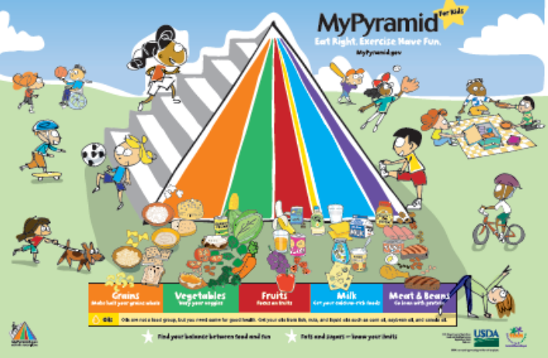
#72
Determine differences within the same foods.

DISCUSSION:
Several foods have a range of foods with varying fat, sodium, and calorie levels to choose from. Foods such as milk, cottage cheese, cheese, yogurt, and ice cream can have a variety of differences from being Regular to Low Fat, Fat Free, Low Sugar, No Sugar, or even Low Sodium. It is important to know and recognize these differences.

ACTIVITY:
Compare foods that have 3 choices (ie, regular, low fat and fat free).

Determine the differences in nutrients and choose the one that is healthiest.

Record below:

Food Item | How much fat? | How much sodium? | How much sugar?

Can you and your family try the lower fat or lower sugar items? YES NO

Decide which one to try: ______________________________
#73
Eat foods containing whole wheat.

DISCUSSION:
Eat foods containing: whole wheat, whole oats, wild rice, or oatmeal instead of refined flour and sugars. These are good for you because they provide fiber and lots of important vitamins and minerals.

ACTIVITY:

Look at the label.

How is whole wheat advertised? ________________________________________

Why is fiber important in the diet? _______________________________________

What do you look for on the label for fiber? ________________________________

Write down why it is important to have fiber in your diet? ___________________________________________________________________

___________________________________________________________________

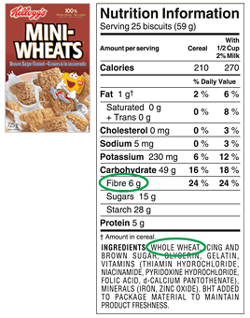
Try a fiber-rich food such as:

- Whole – Wheat bread
- Whole oats
- Wild Rice
- Oatmeal

See if you like these. If you do, start eating them more often!

#74
Eat fiber from a variety of sources.

DISCUSSION:
It's important to eat fiber from a variety of sources to balance the right amount of soluble and insoluble fibers. Fiber tips for kids: The skins of fruits are rich sources of fiber, so don't peel apples and pears. Cut these fruits up into easy-to-eat wedges, but leave the skins on. Also, drink nectar (which contains pulp) rather than fiberless plain juice. Better yet, serve the whole fruit rather than its juice.

ACTIVITY:
Recall any fruit, bean, or whole wheat item you’ve eaten in the past 2 days. Count up the number of fiber and see if it meets your individual fiber needs (your age + 5).

BEST FIBER FOODS
FOOD | SERVING SIZE | TOTAL FIBER (grams)*
AllBran cereal | 1/2 cup | 10-13
Wheat bran | 1/4 cup | 7
High fiber cereals | 1 ounce (1/2 cup) | 10-14
Apple (with skin) | 1 medium | 3.5
Oat bran | 1/4 cup | 4
Prunes | 3 medium | 3
Kidney beans | 1/2 cup | 7.3
Lima beans | 1/2 cup | 4.5
Navy beans | 1/2 cup | 6
Lentils (such as in soup) | 1/2 cup | 3.7
Peas | 1/2 cup | 3.6
Spaghetti (whole wheat) | 1 cup | 3.9
Apricots (dried) | 5 halves | 1.4
Banana | 1 medium | 2.4
Blueberries | 1/2 cup | 2.0
Grapefruit (with membrane) | half | 1.6
Pear | 1 medium | 3.2
Bread (whole wheat) | 1 slice | 1.4
Figs (dried) | 3 medium | 5.3
Potatoes (with skin) | 1 medium | 2.5
Broccoli | 1/2 cup | 2.3
Orange (with membrane) | 1 | 2.6
Spinach | 1/2 cup | 2.1
Pita bread (whole wheat) | 1 piece | 5
Corn | 1 ear | 5
Adapted from Boosting Fiber in Kids, by Leah Perrier R.D. (http://www.healthcastle.com/fiber-kids.shtml)
#75
Know how to support kids with health needs.

DISCUSSION:
Despite taking care of your body, you and other kids can still have health problems that require special needs. Some problems are serious and some are not so serious. When problems are not so serious, sometimes good care is overlooked, but you should remember that staying on top of your treatments and medications today or encouraging a friend or family member with a special health care needs to do so will make a difference when it counts!

For instance, asthma is a condition that affects a person's airways, For most kids, breathing is simple: They breathe in through their noses or mouths and the air goes into the windpipe. From there, it travels through the airways and into the lungs. But for kids with asthma, breathing can be a lot more difficult because their airways are very sensitive

Asthma is more common than you might think. As many as 6 million kids in the United States have it. Asthma affects about one or two kids out of 10. That means if you have 20 kids in your class, two to four of them might have asthma. Asthma can start at any age - even in a little baby or an adult - but it's most common in school-age kids.

You probably know that asthma can cause breathing problems. So can kids with asthma play sports? You bet they can! Being active and playing sports is an especially good idea if you have asthma. Why? Because it can help your lungs get stronger, so they work better

ACTIVITY:
Review with your classmates some ways to help keep asthma under control. You, a friend, or a family member with asthma may need a friendly reminder sometimes.

- take all asthma medication just like your doctor tells you to, even when you are feeling OK.
- when there is lots of pollen in the air, consider skipping outdoor workouts,
- wearing a scarf or ski mask when you play outside during the winter,
- making sure you always have time for a careful warm up and cool down.
- Make sure your coach and teammates know about your asthma. That way, they will understand if you need to stop working out because of breathing trouble. It's also helpful if your coach knows which steps to take if you have a flare-up.
Adapted from Focus on Food, http://www.kidshealth.org/kid/misc/focus_watermelon.html
#76
Stay healthy by fighting bacteria bugs!

DISCUSSION:
Most of us wouldn’t consider food safety as being a part of health and fitness, but following four simple steps can make a significant difference in our health.

ACTIVITY:
Review the Four Simple Steps to Food Safety -- FDA, http://www.foodsafety.gov/~dms/fsebac.html

Clean: Wash hands and surfaces often
Bacteria can spread throughout the kitchen and get onto cutting boards, utensils, sponges and counter tops. Remember:
- Wash your hands with hot soapy water before handling food and after using the bathroom, changing diapers and handling pets.
- Wash your cutting boards, dishes, utensils and counter tops with hot soapy water after preparing each food item and before you go on to the next food.
- Consider using paper towels to clean up kitchen surfaces. If you use cloth towels, wash them often in the hot cycle of your washing machine.

Separate: Don't cross-contaminate
Cross-contamination is the scientific word for how bacteria can be spread from one food product to another. This is especially true when handling raw meat, poultry and seafood, so keep these foods and their juices away from ready-to-eat foods. Remember:
- Separate raw meat, poultry and seafood from other foods in your grocery shopping cart and in your refrigerator.
- If possible, use a different cutting board for raw meat products.
- Always wash hands, cutting boards, dishes and utensils with hot soapy water after they come in contact with raw meat, poultry and seafood.
- Never place cooked food on a plate which previously held raw meat, poultry or seafood.

Cook: Cook to proper temperatures
Food safety experts agree that foods are properly cooked when they are heated for a long enough time and at a high enough temperature to kill the harmful bacteria that cause foodborne illness. Remember:
- When cooking in a microwave oven, make sure there are no cold spots in food where bacteria can survive. For best results, cover food, stir and rotate for even cooking. If there is no turntable, rotate the dish by hand once or twice during cooking.

Chill: Refrigerate promptly
Refrigerate foods quickly because cold temperatures keep harmful bacteria from growing and multiplying. Refrigerate or freeze perishables, prepared food and leftovers within two hours.
- Never defrost food at room temperature. Thaw food in the refrigerator, under cold running water or in the microwave. Marinate foods in the refrigerator.
- Divide large amounts of leftovers into small, shallow containers for quick cooling in the refrigerator.
- Don't pack the refrigerator. Cool air must circulate to keep food safe.

#77
An ounce of prevention keeps germs away.

DISCUSSION:
More than 76 million cases of foodborne illness occur each year. Most times, they simply result in a touch of "tummy flu." An ounce of prevention to keep germs away is easy and inexpensive. It’s worth doing to stay healthy, because getting sick can end up costing you a lot more – in time, money, and energy.

ACTIVITY:

Word Match

1. Two Hour Rule
2. Personal Hygiene
3. Perishable Food
4. Cross-Contamination
5. Contaminated Food
6. Danger Zone
7. Foodborne illness
8. The Thaw Law
9.Sanitation
10.Thorough cooking
- The transfer of harmful bacteria from one food to another.
- Defrost foods in the refrigerator, microwave, or under running water. Never defrost food on the kitchen counter.

- Keeping work areas free from dirt or bacteria.

- Foods that can become unsafe or spoil quickly if not refrigerated or frozen

- Cleanliness, keeping yourself clean.

- Perishable food should not be left at room temperature longer than two hours

- Food that contains harmful bacteria

- Cooking food to a safe internal temperature

- Sickness caused by eating contaminated food, sometimes called food poisoning

- The range of temperatures at which most bacteria multiply rapidly--between 40° and 140° Fahrenheit

FDA, http://www.foodsafety.gov/~dms/fsebac.html

#78
It’s okay to have some fat in your diet.

DISCUSSION:
Having fat in your diet is important because fat is needed to absorb certain vitamins and to make hormones. However, eating too much fat, especially saturated fat, can be unhealthy and may lead to high cholesterol, heart disease, and obesity.

Dietary fat, the kind of fat you get from food, is important for your health and the normal growth and development of your body. Dietary fat has many different functions in your body, which include:
- Providing long lasting energy
- Helping you feel full after eating
- Helping make hormones
- Forming part of your brain and nervous system
- Forming cell membranes for every cell in your body
- Carrying vitamins throughout your body
- Helping regulate your body temperature and keep you warm
- Providing two essential fatty acids, called linoleic acid and linolenic acid, that your body cannot make by itself

ACTIVITY:
Divide up in groups and discuss one of the following questions. Share your responses with the class:
- What part do calories and exercise play in our daily lives?
- What role does fat have in our diets?
- What would happen if we had no fat in our diets?
- What diseases are associated with excess fat intake?

#79
Drink 1% milk or skim milk.

DISCUSSION:
Using fat-free milk has benefits. Dairy fats can be dangerous to our hearts over time, if eaten in large quantities.

ACTIVITY:

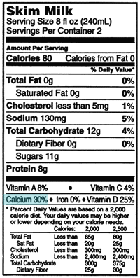
Whole Milk 2% or Lowfat Milk Skim or Nonfat Milk
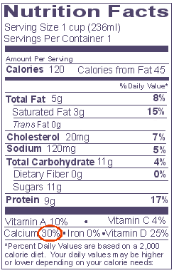
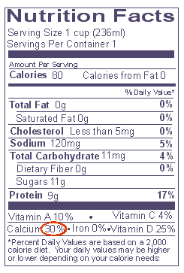

Nonfat
Chocolate
Milk

Look at the labels of the milk provided.

- Compare serving sizes. Are they all the same? Yes No

- Compare the fat content and write them down:
Milk Type | Quantity of Fat

- Determine how much fat you can cut out if using the lower fat milks.

- Each tsp of fat is equal to 5 grams of fat.

- See what your total fat savings can be: ____________________

- Now look at the sugar content. Which one has the most? Why?

#80
Make your meat leaner.

DISCUSSION:
Meat and poultry are favorite sources of essential protein yet they can be high in fat, especially unhealthy saturated fat and cholesterol. Because of this, most healthy diets recommend just modest amounts of these nutritious foods.

ACTIVITY:
Search for each tip in the Word Hunt: White meat
Remove skin
Trim fat
Bake, not fry
Drain fat

A | D | H | Y | T | Z | B | O | G | C | S | E | A | T | O
R | E | M | O | V | E | S | K | I | N | F | A | G | I | V
Q | B | I | P | C | O | N | X | D | H | E | J | R | F | S
Z | R | A | S | T | U | N | P | O | F | T | X | V | E | N
U | M | L | F | A | K | E | M | E | C | S | T | R | D | R
R | J | M | U | E | Q | V | G | W | I | H | F | A | R | B
S | D | B | K | M | I | A | U | K | J | B | S | G | A | T
C | A | R | N | E | Z | O | F | I | Q | T | V | K | I | U
E | K | P | M | T | O | I | H | D | A | M | E | W | N | M
L | I | T | R | I | M | F | A | T | K | N | G | D | F | P
W | P | Q | O | H | X | E | J | L | O | B | R | H | A | Q
J | T | K | B | W | F | D | P | T | W | X | M | G | T | L
R | M | F | A | M | P | K | F | Y | V | T | F | L | H | J
X | Q | F | L | A | E | R | W | O | R | C | R | Y | I | K
Y | O | H | U | N | Y | A | B | V | Q | D | K | E | N | U
#81
Learn the different types of fat – good and bad.

DISCUSSION:
The four main types of fat found in food are monounsaturated fat, polyunsaturated fat, saturated fat, and trans fat. Most foods have a different balance of these types of fats, but are usually classified by the type of fat they are highest in.

Monounsaturated fat is considered the most "heart healthy" type of fat that can decrease LDL ("bad") cholesterol and increase HDL ("healthy") cholesterol. Good sources of monounsaturated fat include: avocados, almonds, canola oil, cashew, olive oil, and peanut butter.

Polyunsaturated fat is also a "heart healthy" type of fat. There are two -- linolenic (omega 3 fatty acids) and linoleic -- that your body uses to make chemicals that control blood pressure, blood clotting, and your immune system response. Good sources of polyunsaturated fat include: corn oil, sardines, sesame seeds, soybeans, flaxseeds, tuna, pine nuts, salmon, herring, walnuts. Sources of Omega-3 fats include: fish, flaxseed, green leafy vegetables, legumes, nuts, soy, tuna.

Saturated fat is NOT “heart healthy” and is also called "animal fat" because it is found in foods that originally come from animals. Sources of saturated fats: butter, cheese, ice cream, whole milk, lard, poultry skin, cream, eggs, red meat.

Trans fat is formed when liquid oils are made into solid fats. Trans fats are artificially produced by food manufacturers. And are NOT healthy. Sources of trans dietary fat include: cookies, crackers, fried foods, muffing, donuts, fast food, and margarine.
Written by the Center for Young Women's Health Staff

ACTIVITY:
For each food item below, identify the type of fat it is. Then circle the “good” fats.

Oreos
Walnuts
Peanut butter
Fried chicken
Muffins
Kale
Tuna
Soy

#82
Meet the humble avocado.

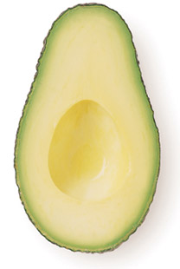
DISCUSSION:
Avocados are a surprisingly complete food, with almost 20 vitamins and minerals, including iron and copper. Because of their density, avocados, like bananas, are filling as well. But they are also a slow-burning fuel, making them ideal for athletes. They contain mono and polyunsaturated fat and make excellent and healthy dips for raw vegetables. When blended with fruit, they make particularly nutritious baby food.
ACTIVITY:
How to grow an avocado house plant – for fun!

Wash an avocado seed. Suspend it (broad end down) over a water-filled glass using three toothpicks. The water should cover about an inch of the seed.
- Place the glass in a warm location, out of direct sunlight. A mature seed will crack as roots and stem sprout in about two to six weeks.
- When a stem grows to six or seven inches, cut it back to about three inches.
- When the roots are thick and the stem has leafed out again, plant it in a rich humus soil, leaving the seed half exposed. Use a terra cotta pot with a 10-1/2" diameter.
- Water your avocado house plant generously, but let it dry out somewhat between waterings.

Proper Care And Feeding Of Your California Avocado House Plant
- Give it frequent, light waterings with occasional deep soakings. Generally, soil should be moist but not saturated.
- The more sunlight your house plant gets, the better.
- If the leaves turn yellow, this is an indication of over watering. Let your house plant dry out for a day or two. If the leaves become brown and fry at the tips, too much salt has accumulated in the soil and leaching is required. Let water run freely into the pot and drain out for several minutes.
- When the stem grows to 12 inches high, cut it back to 6 inches. This will encourage growth of new shoots.
- Don't expect your house plant to bear fruit! Although this does occur occasionally, commercially grown avocados require grafting

California Avocado Board, http://www.avocado.org/kids/house-plant.php
#83
Make humor a part of your healthy lifestyle.

DISCUSSION:
We’ve all heard the news reports of someone who “laughed” his or her way back to health. The concept that comedy could improve health makes some medical sense. Studies show that anger, depression, and pessimism impair the immune response, increase surgical recovery and wound-healing times, and can even contribute to higher death rates. And what better way to counter a negative outlook than through a dose of comedy? "Humor and distressing emotion cannot occupy the same psychological space," says Steven Sultanoff, Ph.D., a clinical psychologist and president of the American Association for Therapeutic Humor

ACTIVITY:
Answers to the wacky things we say.

Tongue in cheek --
This funny-sounding expression indicates that someone just told a joke or isn't being serious! If someone says something "tongue-in-cheek," he or she is usually kidding.
It's believed that this saying was created by an English humorist in the 1800s. Most people have difficulty saying anything with their tongue in their cheek. But some people actually do stick their tongue against the inside of their cheek after saying a joke to show that they're only kidding.
By the skin of your teeth –
If you pass a test by just a few points or win a contest by a tiny bit, people might say you did so "by the skin of your teeth." In other words, you just barely did it. The only problem with this expression is that your teeth don't have skin! But sometimes they have a film on them, especially first thing in the morning. If you feel that sticky film, it's time to brush your teeth!
Under the weather –
When it's gray and rainy out, does that affect how you feel? This expression comes from the idea that bad weather might hurt a person's health and mood. The saying also may be related to "under the weather bow," the part of a boat that will take the force of rough seas during stormy weather. If you were in that part of the boat, you might get seasick!
Have your heart in your mouth –
This expression means that you're really scared or anxious about something. The ancient Greek poet Homer used the phrase thousands of years ago when he wrote the famous poem The Iliad, and people have been using it ever since. When your heart starts pounding so much that you can feel a thumping in your throat, it may feel like you "have your heart in your mouth." But the good news is that your heart can't move into your throat, mouth, or anywhere else. It stays put!
Adapted from Focus on Food, http://www.kidshealth.org/kid/misc/focus_watermelon.html
#84
Blow some bubbles, but don’t swallow the gum!

DISCUSSION:
Almost everyone has swallowed a piece of gum, but few kids have ever needed a doctor because of it. You might have heard that swallowed gum stays in your stomach for 7 years. Not true! Though your stomach can't break down a piece of gum, your digestive system can move it along through your intestines without any problem. In other words, it comes out the other end when you have a “bowel movement” (poop).

The only exception to this would be swallowing a large mass of gum, or many small pieces of gum over a short period of time, which can block the digestive tract in rare cases. Blockage is most likely when gum is swallowed along with foreign objects, like coins, or when swallowed with nondigestible materials like sunflower seeds. Little kids are most likely to be affected because they might not understand that gum is chewed, not swallowed. But apart from these strange scenarios, swallowing an occasional piece of gum is harmless.


Kids shouldn't chew gum until they fully understand the importance of not swallowing it. By age 5, most children will understand that gum is different than candy and is not to be swallowed. So if you have younger brothers or sisters, don't offer them gum until they're older and your mom or dad says it's OK. A good rule would be to stick with sugar-free gum and don't have more than one or two pieces a day. And when you're done with it, don't swallow it. Spit it out instead!
Adapted from Focus on Food, http://www.kidshealth.org/kid/misc/focus_watermelon.html

ACTIVITY:
Have a gum blowing contest to see who can blow the biggest bubble!
#85
Unload the stress in your life.

DISCUSSION/ACTIVITY:
Stress is what you feel when you are worried or uncomfortable about something.This worry in your mind can make your body feel bad. You may feel angry, frustrated, scared, or afraid - which can give you a stomachache or a headache. When you're stressed you may not feel like sleeping or eating. You also may feel cranky or have trouble paying attention at school and remembering things at home.

Plenty of things can cause stress in a kid's life. The trick is to remember that some types of stress are good and others are bad. Good or normal stress might show up when you're called on in class or when you have to give a report. Have you ever gotten butterflies in your stomach or sweaty hands? Those can be signs of good stress - the kind of stress that can help you to get things done.

But bad stress can happen if the stressful feelings keep going over time. You may not feel well if your parents are fighting, if a family member is sick, if you're having problems at school, or if you're going through anything else that makes you upset every day. That kind of stress isn't going to help you, and it can actually make you sick.

Once you recognize that you're feeling stressed, there are several things you can do.
- Try talking about what's bothering you with an adult you trust, like a parent or teacher. Bring up what's been on your mind and how it makes you feel. An adult may have ideas about how to solve whatever is worrying you or making you uncomfortable.
- Inhale (breathe in) slowly and deeply through your nose, then exhale slowly through your mouth. Do this four times slowly (too quickly may cause you to get dizzy).
- Tense and relax all your muscles in you body, beginning with the toes and work your way up to your head.
- Consider dropping an activity if you feel too busy all the time.
- Unwind with a good book.
- Go on a long walk or hike.
- Take a warm, relaxing bath.
- Get a massage.
- Have some quiet, down time to meditate.
- Exercise if it helps relieve stress.

Adapted from Focus on Food, http://www.kidshealth.org/kid/misc/focus_watermelon.html
#86
Stray from your usual fare when eating out.

DISCUSSION:
At fast food places, try something new and healthier! You’ll never know if you like it until you try it. For instance, instead of the usual burger and fries, try the chef salad with grilled chicken. Or make it a point to eat fish whenever you are eating out. Just step out of your normal “lunch box” and try a new food selection every few weeks.

ACTIVITY:
What changes would you make to this typical fast food meal?

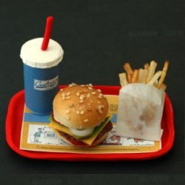
.

#87
Limit junk and fried food.

DISCUSSION:
Our bodies use nutrients from the foods we eat to make new cells and to keep existing cells working properly. Our cells, organs and muscles can’t perform their jobs correctly unless we choose foods with the nutrients our bodies need. Junk food fills us with sugar and fat and often lack the nutrients our bodies need.

ACTIVITY:
Did you know: Frying can triple the number of calories in foods.
Look at what it does to a half cup of potatoes.

Boiled = 67 calories
- Hash brown = 163 calories
- French fries = 180 calories

Did you know: Fruits canned in syrup can almost quadruple the number of calories
in foods. Look what it does to one cup of peaches:
- Canned in water = 58 calories
- Fresh = 73 calories
- Canned in juice = 108 calories
- Caned in light syrup = 136 calories
- Canned in heavy syrup = 190 calories
#88
Trade out your high-fat foods for lower-fat ones.

DISCUSSION:
Reduce the amount of high-fat foods you eat with lower fat foods. You eat more calories with foods that pack a lot of calories into a small volume.

ACTIVITY:
Did you know: A 1-ounce bag of potato chips (about 15-20 chips) has the same
number of calories as 2 ½ cups of grapes.

Did you know: A serving of Pringles or Ruffles, or Lay’s potato chips has about 10
times as much fat as a serving of pretzels.

Did you know: You can eat 6 times as much watermelon as ice cream for the
same number of calories.

Did you know: Three cups of diced watermelon has about the same number of

calories as a ½ cup chocolate ice cream?

Did you know: An entire small cantaloupe has about the same number of calories
as a small (1 ounce) bag of potato chips.


#89
Be flexible and smart when eating out.

DISCUSSION/ACTIVITY:
Healthy eating doesn’t mean you have to prepare ALL of your meals at home for the rest of your life. (Eating mostly at home is still good advice!) If you enjoy eating out, you can certainly do so, in moderation, it just requires a little extra thought and flexibility on your part. Here are a few strategies when dining out:

Choosing the Restaurant –
You should be able to find something healthy to eat at most restaurants, but here are a few things to keep in mind:
- Fat-food restaurants are notorious for featuring high-fat, high-cholesterol, high-sodium, and high-calorie meals. Many do offer healthier alternatives.
- Choose poultry or fish entrees over beef and pork IF they are not breaded and deep fat fried.
- Skip the ‘super sized’ version of your meal. Even if you’re not trying to lose weight, a “biggie” meal is probably more than anyone needs to eat at one sitting. (Some of these super-sized meals have more fat and calories that you need in an entire day!)
- Many places are starting to offer other sides instead of French fries with their combo meals. Take them up on this. Fries often have as many or more calories than the sandwich you ordered!
- Restaurants with salad bars can be a good option. It can certainly make it easier to get all of your daily vegetables and fruits --- and also fill you up.
- Watch out for salad dressings (which may contain a lot of salt and fat). Choose reduced fat dressing or use flavored vinegar and a drizzle of olive oil.
- Limit fatty meats, and cheeses. Choose healthier options like beans, or a light sprinkle of nuts or seeds.
- With ethnic dining there are no absolutes like “all Mexican food is unhealthy” or “Japanese food is good for you.” You have to look at the menu carefully.
#90
Keep your promises to earn screen time.

DISCUSSION/ACTIVITY:
Most kids spend 20 hours or more a week watching TV, playing video games, or surfing the web, and not much time running, playing, or getting physical. Sometimes it helps with the progress if a deal is made. For instance:

- For every 3 hours they surf the web or watch TV, you have to do 1 hour of something physical. Physical doesn' t have to be exercise per se. You can add physical activity throughout the day in a number of ways.

- If you promised when you bought that cute puppy that you would walk the dog, make sure you stick with the promise. Take the frisbee along and you will get even more exercise playing catch with the dog.

#91
Be a fit kid!

DISCUSSION/ACTIVITY:
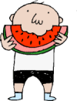
There's a lot of discussion these days about fit kids. Being fit is a way of saying a person eats well, gets a lot of physical activity, and has a healthy weight. While some steps only parents can take — such as serving healthy meals or deciding to take the family on a nature hike, at other times kids can take charge, too, when it comes to health. Here is a summary of the rules to live by, if you're a kid who wants to be fit. The trick is to follow these rules most of the time, knowing that some days (like your birthday) might call for cake and ice cream.

1. Eat a variety of foods, especially fruits and vegetables. You may have a favorite food, but the best choice is to eat a variety to get the nutrients your body needs. Taste new foods and old ones you haven't tried for a while. Shoot for at least five servings of fruits and vegetables a day — two fruits and three vegetables.
2. Drink water and milk most often. When you're really thirsty, cold water is the No. 1 thirst-quencher. Kids also need calcium to grow strong bones, and milk is a great source of this mineral. Aim for 3 cups of milk per day, or its equivalent.
4. Limit screen time. Limit screen time. What's screen time? It's the amount of time you spend watching TV or DVDs, playing video games (console systems or handheld games), and using the computer. The more time you spend on these sitting-down activities, the less time available for active stuff, like basketball, bike riding, and swimming. Try to spend no more than 2 hours a day on screen time, not counting computer use related to school.
5. Be active. One job you have as a kid — and it's a fun one — is that you get to figure out which activities you like best. Not everyone loves baseball or soccer. Maybe your passion is karate, or kickball, or dancing. Ask your parents to help you do your favorite activities regularly. Find ways to be active every day. You might even write down a list of fun stuff to do, so you can refer to it when your mom or dad says it's time to stop watching TV or playing computer games!

Speaking of parents, they can be a big help if you want to be a fit kid. For instance, they can stock the house with healthy foods and plan physical activities for the family. Tell your parents about these five steps you want to take and maybe you can teach them a thing or two. If you're a fit kid, why shouldn't you have a fit mom and a fit dad?

Adapted from Focus on Food, http://www.kidshealth.org/kid/misc/focus_watermelon.html
#92
Balance your “energy budget”.

DISCUSSION:
Energy balance describes the relationship between what you eat and drink IN and what you burn OUT. You burn a certain number of calories just by breathing and digesting. A big person burns more calories every day than a small person. You also burn a certain number of calories through your daily routine.
.
The same amount of energy IN and energy OUT over time
= weight stays the same
More IN than OUT over time = weight gain
More OUT than IN over time = weight loss

Your energy IN and OUT don't have to balance exactly every day. It's the balance over time that determines whether you can maintain a healthy weight in the long run. And, because children need energy to grow properly, energy balance in children happens when the amount of energy IN and energy OUT supports natural growth without promoting excess weight gain. (WeCan, NIH, http://www.nhlbi.nih.gov/health/public/heart/obesity/wecan/learn-it/balance.htm)

ACTIVITY:
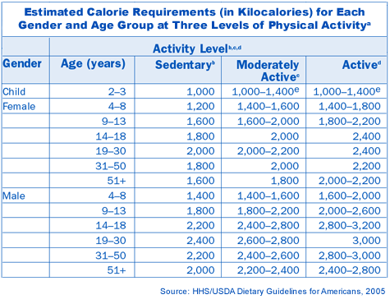
To give you a sense of how many calories you and your family need see the Estimated Calorie Requirement chart. This chart shows the calorie level health experts recommend by gender and age level, also factoring in a person's overall level of activity.
#93
Wean the screen!

DISCUSSION:
One of the biggest challenges to being more physically active for many Americans is the amount of sedentary time children and families spend in front of screens—TV, computer, video games, DVDs and such.
Did you know:
Every day, on average, 8 to 18-year-olds spend:

Nearly four hours watching TV, videos, DVDs, and prerecorded shows
- Just over one hour on the computer
- About 50 minutes playing video games.
- Two-thirds of 8 to 18-year-olds have a TV in their bedroom and a video game player, and nearly one-third have a computer in their bedroom.
- Children and teens who have TVs in their rooms spend almost 1 ½ hours or more a day watching TV than their peers without a set in their rooms.
(According to the Henry J. Kaiser Foundation's survey, "Generation M: Media in the Lives of 8-18 Year Olds," March 2005)
It's time to wean the screen!

ACTIVITY:
Individually and/or with your family, set and agree on a certain number of hours each day of "screen time". Health experts recommend two hours or less a day that is not work- or homework-related time, such as watching documentary films or doing research or writing on a computer. Record the number of house of screen time on the following chart. Discuss your experiences with the class at a later date.

 | TV | Video Games | DVD | Computer/Internet | Time (hours)
Monday
Tuesday
Wednesday
Thursday
Friday
Saturday
Sunday
TOTAL
http://www.nhlbi.nih.gov/health/public/heart/obesity/wecan/learn-it/balance.htm
#94
Learn the difference of “Go, Slow, Whoa” foods!

DISCUSSION:
Here's something kids can do to eat healthier: Learn the difference between Go, Slow, and Whoa foods. It’s a new classification system by the National Heart, Lung, and Blood Institute to get kids thinking about whether foods are go foods, slow foods, or whoa foods.
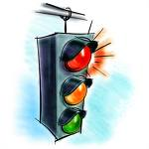
Go Foods
These are foods that are good to eat almost anytime. They are the healthiest ones. Example: skim and low-fat milk.
Slow Foods
These are sometimes foods. They aren't off-limits, but they shouldn't be eaten every day. At most, eat them several times a week. Example: waffles and pancakes.
Whoa Foods
These foods should make you say exactly that — Whoa! Should I eat that? Whoa foods are the least healthy and the most likely to cause weight problems, especially if a person eats them all the time. That's why Whoa foods are once-in-a-while foods. Example: French fries.

ACTIVITY:
Go though the lists below and figure out in which category some of your favorite foods are. Then, learn to say go, slow, and whoa!

Go Foods (beneficial to eat almost anytime) - low in saturated fat and cholesterol.
- Various fresh vegetables: broccoli, peppers, carrots, tomatoes, etc.
- Various fresh fruits: apples, oranges, bananas, berries, etc.
- Oil & Vinegar
- Whole grain bread
- Whole grain Pasta (1 cup cooked)
- Whole grain cereal (unsweetened) (1 cup)
- Fat free milk (1 cup)
- Reduced fat or fat-free cheese (2 ounces cubed)
- Baked potato with fat free sour cream
- Extra lean hamburger (3 ounces cooked) on whole-wheat bun
- Skinless chicken (3 ounces cooked)
- Low fat microwave popcorn (3 cups)
- Ginger snaps (80 to 100 calories worth)
- Low fat frozen yogurt or ice cream (1/2 cup)
- Fig bars (80 to 100 calories worth)
- Water
- Diet soda
- Diet iced tea
Slow Foods are foods that should be eaten sometimes, at most several times a week. These are generally higher calorie, higher fat foods that kids are encouraged to eat only sometimes -- so they can leave room for other more nutrient-dense foods.
- Any veggie dish with added sauce/fat (i.e. Broccoli in a cream sauce)
- Dried fruit (1/4 cup)
- Canned fruit in light syrup (1 serving)
- 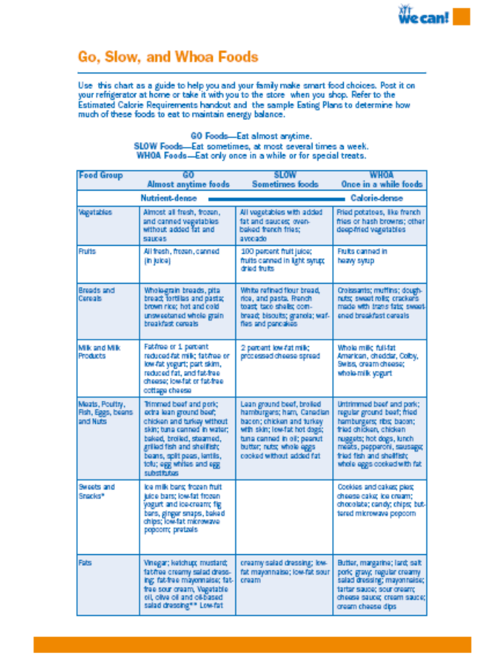French toast (2 slices made with whole grain bread)
- Biscuits (1)
- Granola (1/4 cup)
- Chicken with skin (3 ounces cooked)
- Natural peanut butter (1 Tbsp) on whole-wheat crackers (4 or 5)
- Nuts (2 tablespoons)
- 100 percent fruit orange juice (1 cup)
- Sports drink (1 cup)
Whoa Foods are foods that should only be eaten once in a while or for special treats. They are typically high in saturated fat and dietary cholesterol and, in some cases, high in sugar.
- French fries
- Canned fruit in heavy syrup
- Doughnuts
- Croissants
- Full fat cheese
- Whole milk
- One slice of pizza
- Fried chicken
- Hot dog in a bun
- Regular ice cream
- Cookies
- Regular soda
- Fruit punch

NIH, We Can Curriculum, http://www.nhlbi.nih.gov/health/public/heart/obesity/wecan/learn-it/balance.htm
#95
Stay active for all seasons and reasons.

DISCUSSION/ACTIVITY:
With activities planned for all seasons and all reasons, it should be easy to remain active all year around. No matter what the weather is like or how many friends are around, there's always a way to be physically active and have fun. Here's how.

When It's Just You
By yourself? Try hopping on your bike, strapping on your skates, or grabbing your skateboard. Don't forget your helmet and pads! Or try jumping rope and counting how many times you can jump before you miss. Sometimes being by yourself gives you a chance to practice stuff so you get better at it. If you play tennis, try hitting a tennis ball against a brick wall. If basketball's your thing, try shooting hoops and seeing how many you can sink. Or if you're into soccer, grab a ball, and see how long you can keep it in the air using your feet, knees, and head. When you play with your friends again, they'll be amazed at what you can do!
More things to do when it's just you:
- Practice hopscotch
- See how long you can hop on one foot.
- Do jumping jacks.
- Invent some dance moves.
- Do sprints (short running races) and time yourself to see how fast you go.
- Use a pedometer to count the number of steps between your favorite places, like your house and the park.

When There Are Two
Just you and a friend hanging out, looking for something to do? Practice playing some Ping-Pong or start a tennis tournament between the two of you. Ever try badminton? It's great if you have a net, but you also can play by just seeing how many times you can hit the birdie back and forth to each other. How about a little one-on-one in basketball or a race to see who's the fastest runner? Maybe you're into cheerleading. If so, invent some new cheers together.
More things to do when there are two:
- Have a handstand contest.
- Invent dances to your favorite songs.
- Jump rope together.
- Ride bikes and don't forget your helmets!
- Practice pitching and hitting a baseball.

When There Are a Lot of You
If there are a bunch of kids looking for something cool to do, you're in luck! Lots of sports and games work well with a group of kids. Baseball, softball, basketball, soccer, and volleyball are good group games. Or you might play follow the leader on bikes, blades, or skates.
More things to do when there are a lot of you:
- Have a skateboarding contest.
- Play tag.
- Play outdoor hide-and-seek.
- Dance to your favorite music.

When It's Cold Outside
Brrr! Warm up fast and get those muscles moving by shoveling the snow off the driveway or the sidewalk. You might even offer to shovel the driveways or sidewalks for people in your neighborhood. Make some giant snow people or other snow creatures. Build an igloo or a fort, and store all your snowballs there.If you live near an ice-skating rink or pond, strap on those skates and glide across the ice. If skiing is more your thing, put on your skis and go because both downhill and cross-country skiing are great ways to exercise. Or see the snow rushing past you from a sled, snowboard, or tobaggan. More things to do when it's cold:
- Play tag in the snow.
- Take a nature hike and look for animal footprints.
- Pull a little kid around on a sled.
- Make snow angels.

When It's Hot, Hot, Hot
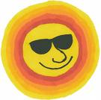
What do you do? Swim, of course! Race your friends or show off your underwater skill by doing a handstand. But don't forget the safety rules. Make sure there's an adult around to watch you and no dunking! On land, you can have a water balloon toss with friends. Catch that balloon, or you'll get soaked!
More things to do when it's hot:
- Take a nature walk on a shady trail.
- Wash your dog outside.
- Wash your parents' or neighbors' car.
- Turn on the sprinkler and cool off!

When You're Stuck at Home
Maybe you can't go out because the weather is rainy or too cold. Turn on your favorite music and dance. Invite your dog or cat to join in the fun. Or grab a hula hoop and make up some hula-hoop dances. If there is enough room, you can jump rope and count how many times you jump without missing. There are basketball hoops with over-the-door hooks and basketballs made from soft foam that are meant to be played with indoors. If you have them and there is enough room, set them up and shoot some hoops. Have a tournament with everyone in the house - may the best basketball player win!
More things to do when you're stuck at home:
- Do some tumbling if you have enough room to do it.
- Set up a scavenger hunt.
- Bat a balloon back and forth and try not to let it hit the floor.

And here's one thing not to do: Try not to say, "I'm bored. There's nothing to do." As you just found out, there's always something to do!

Adapted from Focus on Food, http://www.kidshealth.org/kid/misc/focus_watermelon.html
#96
Cut the caffeine.

DISCUSSION:
Caffeine is a natural, common chemical found in tea leaves, coffee beans, cacao (the stuff used to make chocolate), and cola nuts (the plant that gives cola soda its flavor). Caffeine has been in foods that humans eat and drink for hundreds of years. Today, caffeine is found in many common foods and drinks, such as coffee, tea, hot cocoa, soda, chocolate, and some medicines.

In humans caffeine acts as a stimulant which may make us temporarily feel more awake and alert, given that it can cause you heart to pump faster. Many people drink liquids with caffeine because they think it helps them to wake up and feel sharper. But no one needs caffeinated drinks, especially kids. It isn’t a nutrient. The best drinks for kids are still water and milk, which don't contain caffeine.

ACTIVITY:
If you like soda once in a while, try to choose one that doesn’t contain caffeine (and preferrably without sugar). Clear lemon-lime sodas usually don’t, but just to be sure – read the label or refer to this chart.

Caffeine Chart
Drink/Food | Amount of Drink/Food | Amount of Caffeine
Mountain Dew | 12 ounces | 55.0 mg
Coca-Cola | 12 ounces | 34.0 mg
Diet Coke | 12 ounces | 45.0 mg
Pepsi | 12 ounces | 38.0 mg
7-Up | 12 ounces | 0 mg
Brewed coffee (drip method) | 5 ounces | 115 mg*
Iced tea | 12 ounces | 70 mg*
Dark chocolate | 1 ounce | 20 mg*
Milk chocolate | 1 ounce | 6 mg*
Cocoa beverage | 5 ounces | 4 mg*
Chocolate milk beverage | 8 ounces | 5 mg*
Cold relief medication | 1 tablet | 30 mg*
This is an average amount of caffeine. That means some of these products may contain a little more caffeine; some may contain a little less. Source: U.S. Food and Drug Administration and National Soft Drink Association
#97
Substitute high-fat with low-fat ingredients.

DISCUSSION:
Change the ingredients in your favorite dessert. A regular shake has 630 calories. To make a healthier, sweet frozen drink, mix 1 cup frozen strawberries (without syrup) ½ tsp vanilla extract, 1 cup low-fat, vanilla Yogurt and 1 cup ice cubes in a blender until frothy.


Other general tips:
- Use substitute eggs
- Use fat substitutes such as applesauce
- Use fat-free milk instead of other milks
- Use Canadian Bacon instead of bacon
- Use lower fat cheeses –mozzarella
- Bake instead of fry

ACTIVITY:
Modify the following high-fat omelette recipe to be a lower fat version. If no substitution is warranted, write N/A. Give it a try at home!

. Original Ingredients Modified Ingredients

2-3 eggs, beaten together .

1 piece of bacon .

1 oz. Gruyère cheese, shredded .

A pinch of chopped chives .

1 Tablespoon cream .

1-2 teaspoons of unsalted butter .

1 Tablespoon sour cream garnish .

Answers: Use egg substitute; canadian bacon; part skim mozzarella; chives ok; skim milk; pan spray, fat free sour cream.
#98
Use applesauce instead of margarine.

DISCUSSION:
Many recipes incorporate a lot of margarine or fat for flavor and taste. These two items are not good for us in large quantities. There are many substitute ingredients that we can use to help reduce the fat content of recipes. However, most of these substitutes are only used in baked items. A favorite substitution is to use applesauce instead of margarine in baked foods to reduce the fat content. Research some recipes and see if you can use substitutes to reduce the fat.

ACTIVITY:
There are many ways to reduce the fat in recipes. Below are ideas on how to reduce the fat in cooking. Take this sheet to mom and help her cook by reducing the fat in the recipes.

Sources of fat: | Try these substitutions:
Butter | Margarine (look for 0 grams of trans fat on the nutrition facts label)
Cheese | Low fat or reduced fat cheese
Coconut | Nuts
Coconut Oil | Canola oil
Cream | Low fat milk or fat free creamer
Eggs | Egg substitute
Ice Cream | Frozen yogurt or reduced fat ice cream
Lard | Oil or all-vegetable shortening (look for 0 grams of trans fat on the nutrition facts label)
Palm or Palm Kernal Oil | Canola oil
Poultry Skin | Poultry without the skin
Red Meat | White meat poultry or fish
Whole Milk | Skim or 1% Milk

#99
Exercise your brain by doing puzzles.

DISCUSSION:
Puzzles and brain-teasers are a good way to keep our brains in shape as we get older.
There are many fun activities out there (especially in the internet) that help keep our minds sharp while still learning about health and nutrition.
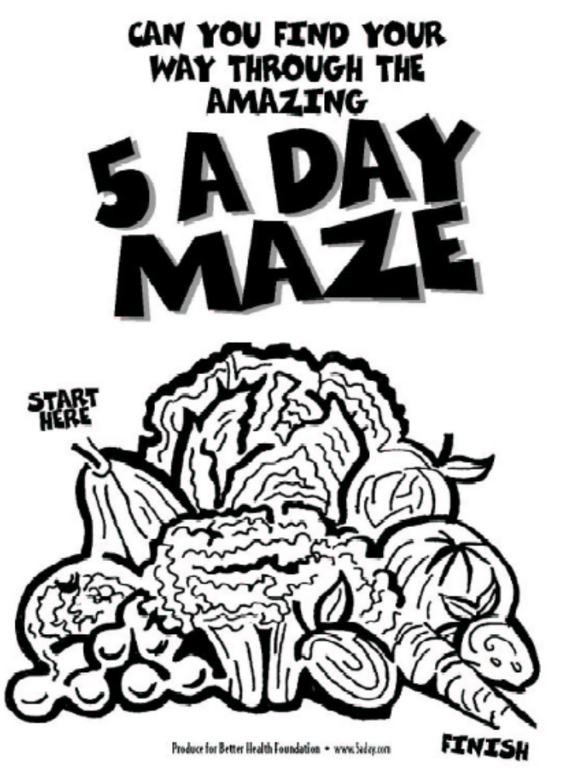
ACTIVITY:
Do a puzzle on healthy foods and time yourself to completion. How long did it take you to finish? Check out other activities in the packet that you can do. Take this home, for there are recipes that the adults in the house can use.

#100
Review the “100 Habits” and celebrate change!

DISCUSSION:
Congratulations! You made it!

ACTIVITY:
- Review each of the “100 Habits to Better Health”.
- Circle the ones that have impacted your learning of health, fitness, and nutrition.
- Highlight the ones that you have changed in your life.

Celebrate the journey you’ve taken!
- Reinforce success and reward yourself for each habit you’ve changed with a little treat – a new book, or a ticket to the movies
- Keep on going and never give up.





