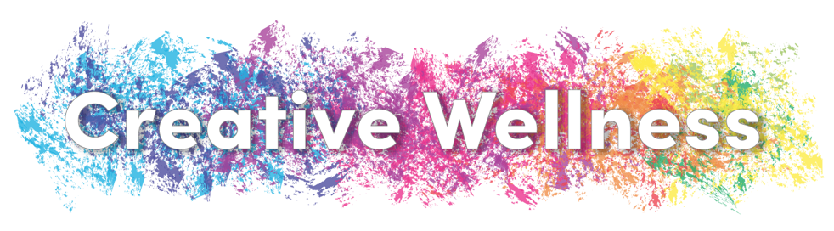

Cystic Fibrosis (CF) and Severe Asthma (SA) are two chronic respiratory diseases that impact every aspect of the patient’s life and the lives of those close to them. The maintenance of these diseases is intense and requires vast amounts of time, energy, and care from both the individuals with the conditions and those caring for them. Research has shown that individuals with CF and SA are 2 to 3 times more likely to experience symptoms of depression and anxiety, and that patients with these diseases are more likely to experience these symptoms if their caregivers experience them. This is significant as difficulties such as these are associated with worse health outcomes, the ability for patients to stick to their treatment regimen, and quality of life, as well as increased sickness, hospitalizations, and healthcare costs. This project is called Creative Wellness and focuses on the mental health and well-being of patients with CF and SA as well as their caregivers, as mental health and physical health are so powerfully intertwined.

Creative Wellness will employ the proven practices of mindfulness and expressive writing in an effort to determine whether these practices positively impact patient and caregiver well-being. These practices focus on noticing internal thoughts and emotions and then expressing them in a way that facilitates release. They have been shown to reduce symptoms of depression and anxiety. Creative Wellness will deliver 1-hour workshops to patients with CF and SA and their caregivers, separately, in which they will be taught basic tenets of mindfulness and expressive writing and engage in curated exercises of both. Participants will also receive a packet of activities that can be used to continue practicing what was learned during the workshop. Participants will complete a survey before and after the workshop to measure their enjoyment of the exercises, impact on well-being, and whether they will use these skills throughout their everyday lives.

