Instructions for Making “Cystic Fibrosis: Infant & Child Nutrition” Flip Chart
This project was developed by Stephanie Lu, MPH, RD
2009-2010 Nutrition Trainee at the Pediatric Pulmonary Center, The University of Arizona College of Medicine
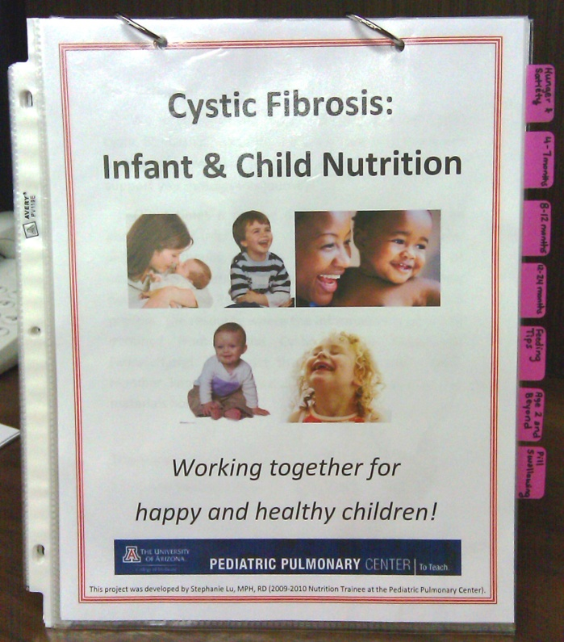
Ingredients:
- 17 sheets of 8 ½ x 11 inch computer paper
- 17 sheet protectors
- 7, 1 inch durable tabs
- 2, 1 inch metal book rings
- 1, 8 ½ x 11 inch slanted stand-up presentation sign holder
- Color printer
- 2-hole puncher (or single hole puncher)
- Drill with ___bit-size
Instructions:
- Drill two holes into sign holder
- Line up a piece of paper to the sign holder and mark with a pencil where the holes are so you can line up all the pages to the same holes
- Print each provided file one-sided
- Insert one sheet per sheet protector
- Punch holes through sheet protector and inserted sheet based on sign holder holes
- Write on tabs the topics for each hand-out
  - Hunger and Satiety
  - 4-7 months
  - 8-12 months
  - 12-24 months
  - Feeding Tips
  - Age 2 and Beyond
  - Pill Swallowing
- Line up pages by holes and put in metal rings through the sign holder as well

